Lesson 16
Objective: Solve two-step word problems using the standard subtraction algorithm fluently modeled with tape diagrams, and assess the reasonableness of answers using rounding.

Suggested Lesson Structure
 Fluency Practice (12 minutes)
 Application Problem (5 minutes)
 Concept Development (30 minutes)
 Student Debrief (13 minutes)
Total Time (60 minutes)
Fluency Practice (12 minutes)
- Sprint: Convert Meters and Centimeters to Centimeters 4.MD.1 (8 minutes)
- Compare Numbers 4.NBT.2 (4 minutes)
Sprint: Convert Meters and Centimeters to Centimeters (8 minutes)
Materials: (S) Convert Meters and Centimeters to Centimeters Sprint
Note: Reviewing unit conversions that were learned in Grade 3 helps to prepare the students to solve problems with meters and centimeters in Module 2, Topic A.
Compare Numbers (4 minutes)
Materials: (S) Personal white board
Note: Reviewing this concept helps students work towards mastery of comparing numbers.
T: (Project 342,006 _____ 94,983.) On your personal white boards, compare the numbers by writing the greater than, less than, or equal symbol.
S: (Write 342,006 > 94,893.)
Repeat with the following possible sequence: 7 thousands 5 hundreds 8 tens ______ 6 ten thousands 5 hundreds 8 ones, and 9 hundred thousands 8 thousands 9 hundreds 3 tens ______ 807,820.
Application Problem (5 minutes)
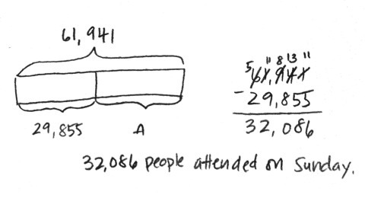
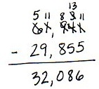
For the weekend basketball playoffs, a total of 61,941 tickets were sold. 29,855 tickets were sold for Saturday’s games. The rest of the tickets were sold for Sunday’s games. How many tickets were sold for Sunday’s games?
32,086 tickets were sold for Sunday’s games.

Note: This Application Problem reviews content from the prior lesson of using the subtraction algorithm with multiple regroupings.
Concept Development (30 minutes)
Materials: (S) Personal white board
Problem 1: Solve a two-step word problem, modeled with a tape diagram, assessing reasonableness of the answer using rounding.
A company has 3 locations with 70,010 employees altogether. The first location has 34,857 employees. The second location has 17,595 employees. How many employees work in the third location?
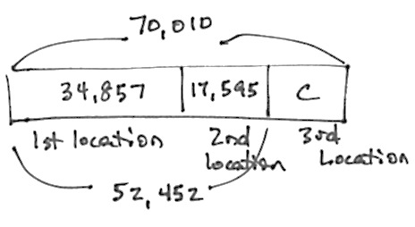
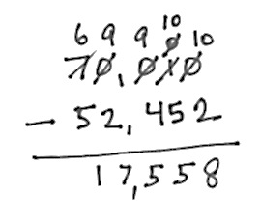

T: Read with me. Take 2 minutes to draw and label a tape diagram. (Circulate and encourage the students: “Can you draw something?” “What can you draw?”)
T: (After 2 minutes.) Tell your partner what you understand and what you still don’t understand.
S: We know the total number of employees and the employees at the first and second locations.
We don’t know how many employees are at the third location.
T: Use your tape diagram to estimate the number of employees at the third location. Explain your reasoning to your partner.
`
NOTES ON
MULTIPLE MEANS
OF ACTION
AND EXPRESSION:
Students working below grade level may not consider whether their answer makes sense. Guide students to choose the sensible operation and check their answers. Encourage students to reread the problem after solving and to ask themselves, “Does my answer make sense?” If not, ask, “What else can I try?”

S: I rounded the number of employees.
30,000 + 20,000 = 50,000, and I know that the total number of employees is about 70,000. That means that there would be about 20,000 employees at the third location.
T: Now, find the precise answer. Work with your partner to do so. (Give students time to work.)
T: Label the unknown part on your diagram, and make a statement of the solution.
S: There are 17,558 employees at the third location.
T: Is your answer reasonable?
S: Yes, because 17,558 rounded to the nearest ten thousand is 20,000, and that was our estimate.
Problem 2: Solve two-step word problems, modeled with a tape diagram, assessing reasonableness of the answer using rounding.
Month | Month 1 | Month 2 | Month 3 | Month 4
Visitors | 228,211 | 301,856 | 299,542
Owen’s goal is to have 1 million people visit his new website within the first four months of it being launched. Below is a chart showing the number of visitors each month. How many more visitors does he need in Month 4 to reach his goal?
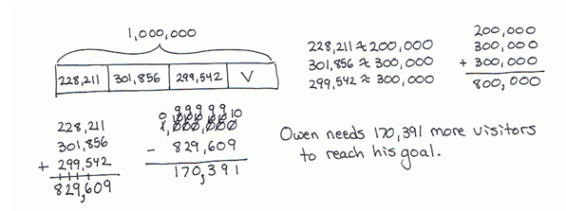

T: With your partner, draw a tape diagram. Tell your partner your strategy for solving this problem.
S: We can find the sum of the number of visitors during the first 3 months. Then, we subtract that from 1 million to find how many more visitors are needed to reach his goal.
T: Make an estimate for the number of visitors in Month 4. Explain your reasoning to your partner.

S: I can round to the nearest hundred thousand and estimate. Owen will need about 200,000 visitors to reach his goal. I rounded to the nearest ten thousand to get a closer estimate of 170,000 visitors.

NOTES ON
MULTIPLE MEANS
OF ENGAGEMENT:
Challenge students working above grade level to expand their thinking and to figure out another way to solve the two-step problem. Is there another strategy that would work?
T: Find the total for the first 3 months. What is the precise sum?
S: 829,609.
T: Compare the actual and estimated solutions.
Is your answer reasonable?
S: Yes, because our estimate of 200,000 is near 170,391. Rounded to the nearest hundred thousand, 170,391 is 200,000. 170,391 rounded to the nearest ten thousand is 170,000 which was also our estimate, so our solution is reasonable.
Problem 3: Solve a two-step, compare with smaller unknown word problem.
There were 12,345 people at a concert on Saturday night. On Sunday night, there were 1,795 fewer people at the concert than on Saturday night. How many people attended the concert on both nights?
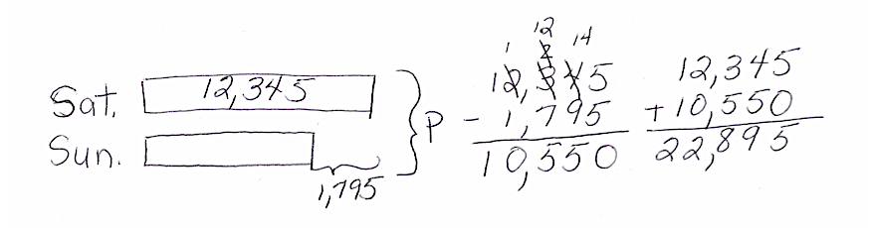
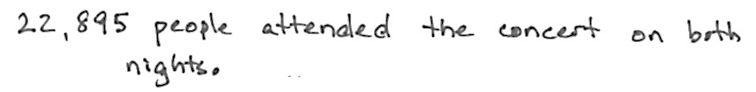

T: For 2 minutes, with your partner, draw a tape diagram. (Circulate and encourage students as they work. You might choose to call two pairs of students to draw on the board while others work at their seats. Have the pairs then present their diagrams to the class.)
T: Now how can you calculate to solve the problem?
S: We can find the number of people on Sunday night and then add that number to the people on Saturday night.
T: Make an estimate of the solution. Explain your reasoning to your partner.
S: Rounding to the nearest thousand, the number of people on Saturday night was about 12,000. The number of people fewer on Sunday night can be rounded to 2,000, so the estimate for the number of people on Sunday is 10,000. 12,000 + 10,000 is 22,000.
T: Find the exact number of people who attended the concert on both nights. What is the exact sum?
S: 22,895.
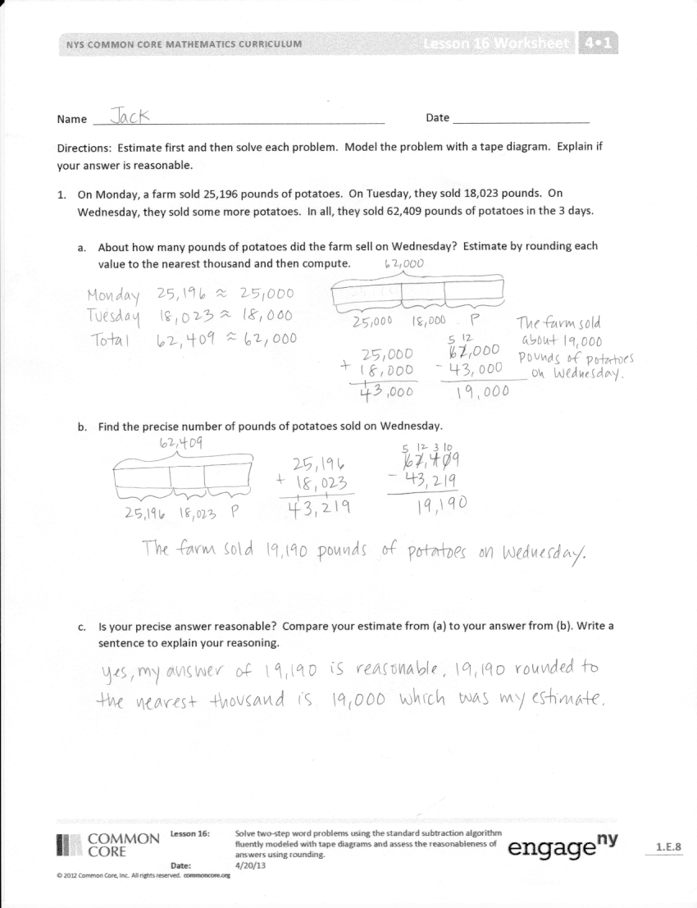
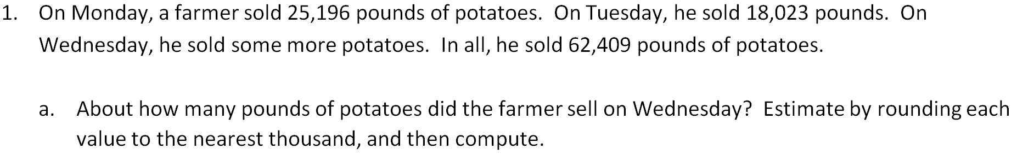
T: Compare the actual and estimated solutions.
Is your answer reasonable?
S: Yes, because 22,895 is near our estimate of 22,000.
T: Be sure to write a statement of your solution.
Problem Set (10 minutes)
Students should do their personal best to complete the Problem Set within the allotted 10 minutes. For some classes, it may be appropriate to modify the assignment by specifying which problems they work on first. Some problems do not specify a method for solving. Students should solve these problems using the RDW approach used for Application Problems.
Student Debrief (13 minutes)
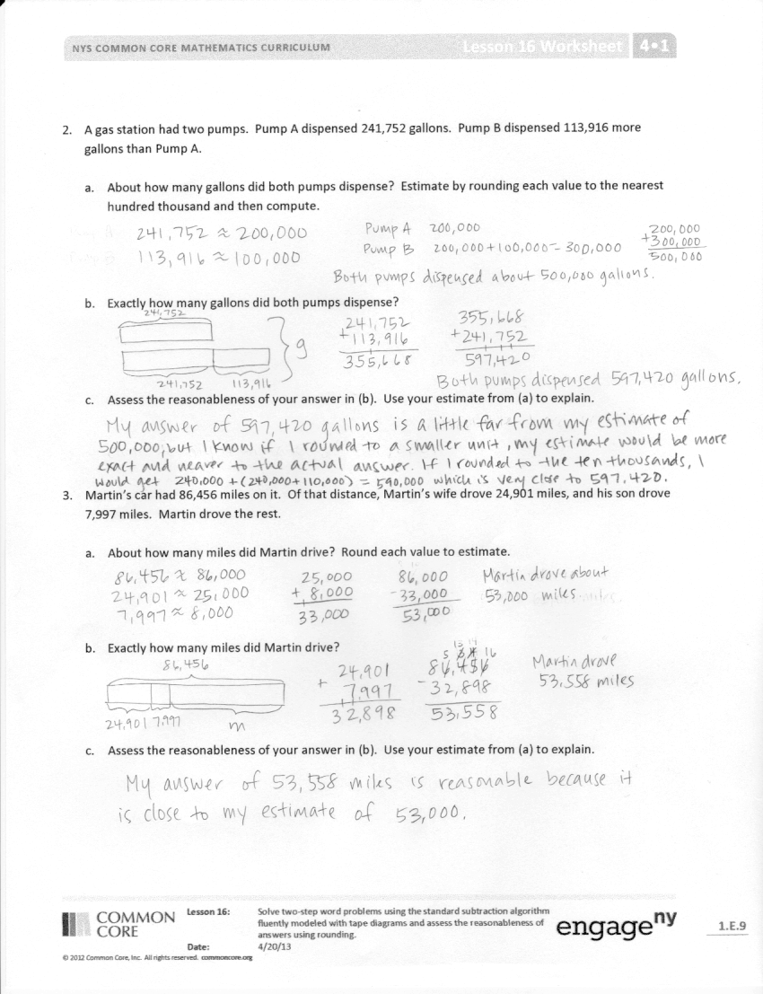
Lesson Objective: Solve two-step word problems using the standard subtraction algorithm fluently modeled with tape diagrams and assess the reasonableness of answers using rounding.
The Student Debrief is intended to invite reflection and active processing of the total lesson experience.
Invite students to review their solutions for the Problem Set. They should check work by comparing answers with a partner before going over answers as a class. Look for misconceptions or misunderstandings that can be addressed in the Debrief. Guide students in a conversation to debrief the Problem Set and process the lesson.
You may choose to use any combination of the questions below to lead the discussion.
- How did your estimate help you determine that your exact answer was reasonable in Problem 1?
- In Problem 2, how close was your actual answer to your estimate?
- Why was the estimate so much smaller than the exact answer in Problem 2?
- In Problem 3, to which place did you round? Why?
- How did your tape diagram help you solve Problem 5?
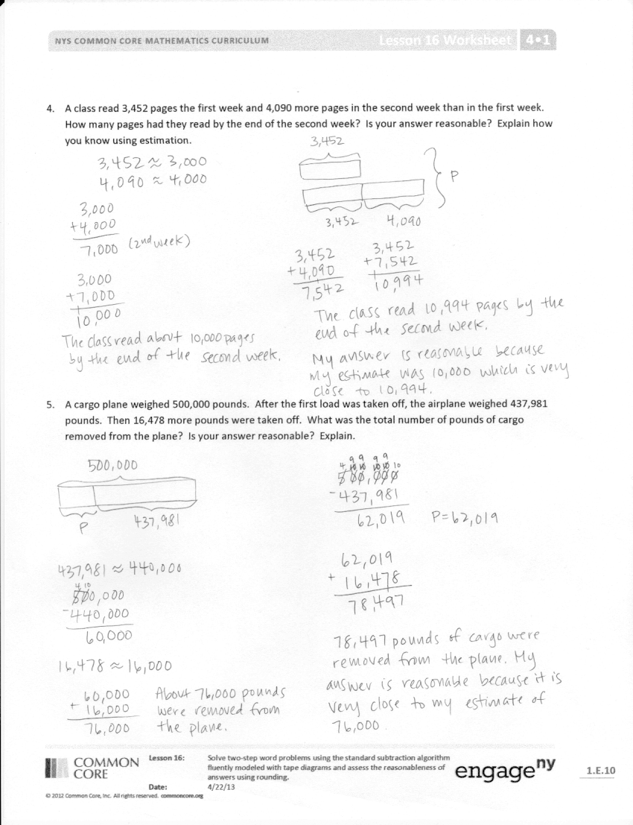
- How do you determine what place value to round to when finding an estimate?
- What is the benefit of checking the reasonableness of your answer?
- Describe the difference between rounding and estimating.
Exit Ticket (3 minutes)
After the Student Debrief, instruct students to complete the Exit Ticket. A review of their work will help you assess the students’ understanding of the concepts that were presented in the lesson today and plan more effectively for future lessons. You may read the questions aloud to the students.

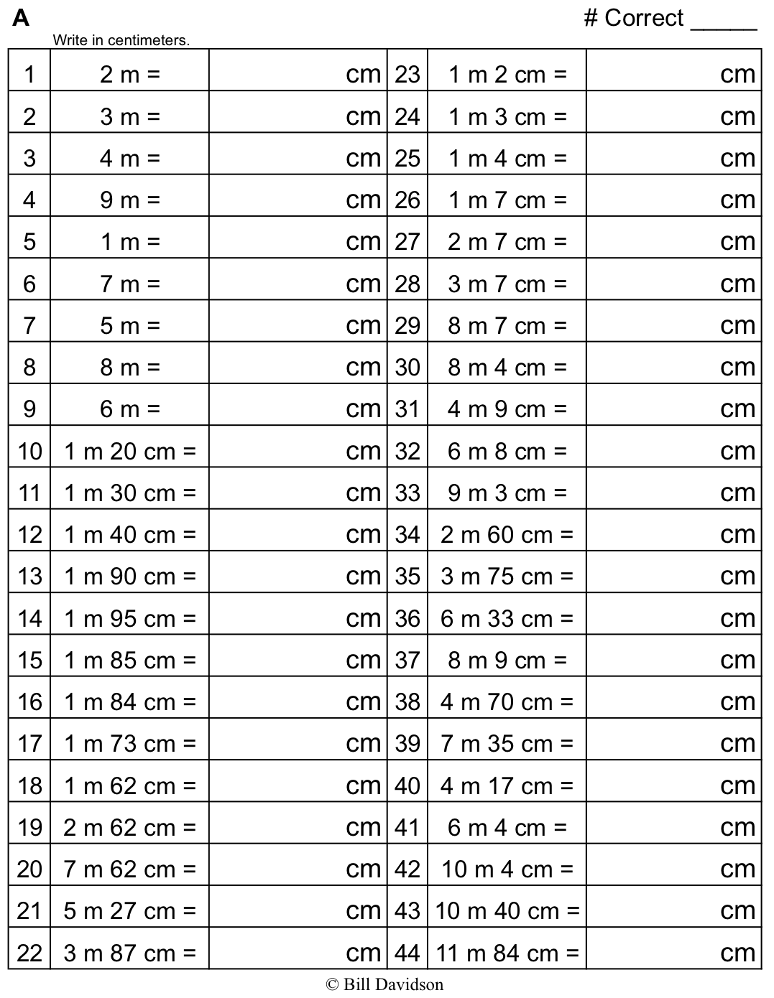
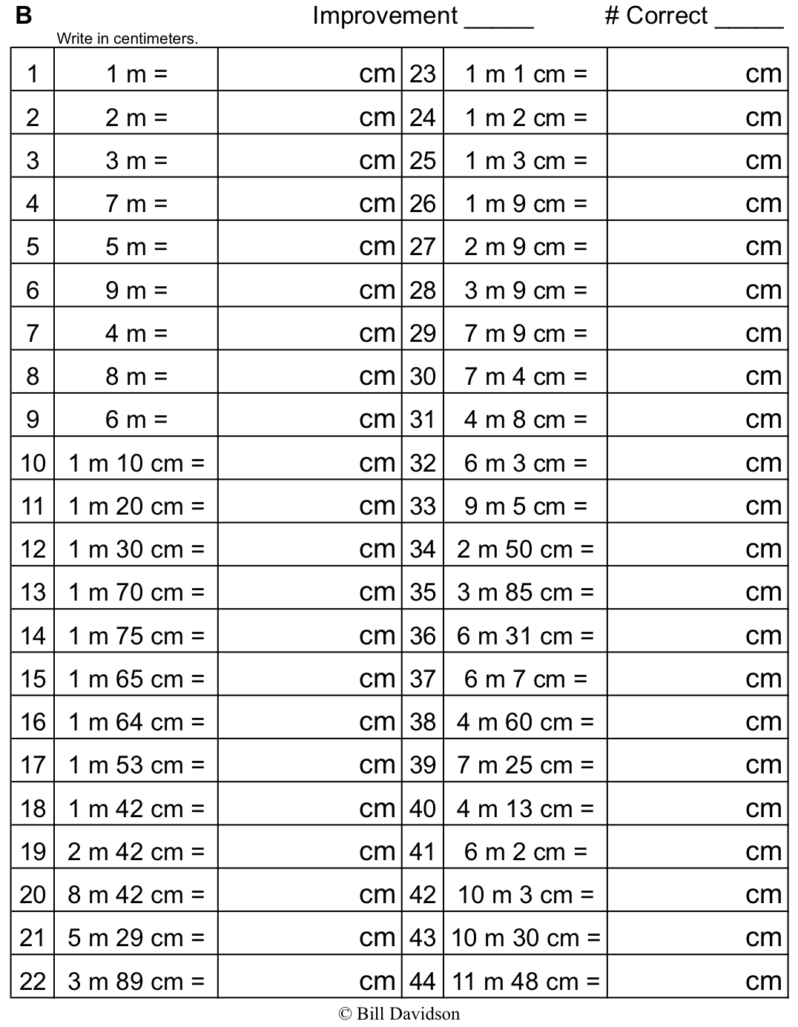
Name Date
Estimate first, and then solve each problem. Model the problem with a tape diagram. Explain if your answer is reasonable.
- On Monday, a farmer sold 25,196 pounds of potatoes. On Tuesday, he sold 18,023 pounds. On Wednesday, he sold some more potatoes. In all, he sold 62,409 pounds of potatoes.
  - About how many pounds of potatoes did the farmer sell on Wednesday? Estimate by rounding each value to the nearest thousand, and then compute.

  - Find the precise number of pounds of potatoes sold on Wednesday.

  - Is your precise answer reasonable? Compare your estimate from (a) to your answer from (b). Write a sentence to explain your reasoning.

- A gas station had two pumps. Pump A dispensed 241,752 gallons. Pump B dispensed 113,916 more gallons than Pump A.
- About how many gallons did both pumps dispense? Estimate by rounding each value to the nearest hundred thousand and then compute.

- Exactly how many gallons did both pumps dispense?

- Assess the reasonableness of your answer in (b). Use your estimate from (a) to explain.

- Martin’s car had 86,456 miles on it. Of that distance, Martin’s wife drove 24,901 miles, and his son drove 7,997 miles. Martin drove the rest.
- About how many miles did Martin drive? Round each value to estimate.

- Exactly how many miles did Martin drive?

- Assess the reasonableness of your answer in (b). Use your estimate from (a) to explain.

- A class read 3,452 pages the first week and 4,090 more pages in the second week than in the first week. How many pages had they read by the end of the second week? Is your answer reasonable? Explain how you know using estimation.

- A cargo plane weighed 500,000 pounds. After the first load was taken off, the airplane weighed 437,981 pounds. Then 16,478 more pounds were taken off. What was the total number of pounds of cargo removed from the plane? Is your answer reasonable? Explain.

Name Date
Quarterback Brett Favre passed for 71,838 yards between the years 1991 and 2011. His all-time high was 4,413 passing yards in one year. In his second highest year, he threw 4,212 passing yards.

- About how many passing yards did he throw in the remaining years? Estimate by rounding each value to the nearest thousand and then compute.

- Exactly how many passing yards did he throw in the remaining years?

- Assess the reasonableness of your answer in (b). Use your estimate from (a) to explain.

Name Date
- Zachary’s final project for a college course took a semester to write and had 95,234 words. Zachary wrote 35,295 words the first month and 19,240 words the second month.

- Round each value to the nearest ten thousand to estimate how many words Zachary wrote during the remaining part of the semester.

- Find the exact number of words written during the remaining part of the semester.

- Use your answer from (a) to explain why your answer in (b) is reasonable.

- During the first quarter of the year, 351,875 people downloaded an app for their smartphones. During the second quarter of the year, 101,949 fewer people downloaded the app than during the first quarter. How many downloads occurred during the two quarters of the year?
  - Round each number to the nearest hundred thousand to estimate how many downloads occurred during the first two quarters of the year.

  - Determine exactly how many downloads occurred during the first two quarters of the year.

  - Determine if your answer is reasonable. Explain.

- A local store was having a two-week Back to School sale. They started the sale with 36,390 notebooks. During the first week of the sale, 7,424 notebooks were sold. During the second week of the sale, 8,967 notebooks were sold. How many notebooks were left at the end of the two weeks? Is your answer reasonable?

