Lesson 15
Objective: Use place value understanding to fluently decompose to smaller units multiple times in any place using the standard subtraction algorithm, and apply the algorithm to solve word problems using tape diagrams.

Suggested Lesson Structure
 Fluency Practice (11 minutes)
 Application Problem (6 minutes)
 Concept Development (32 minutes)
 Student Debrief (11 minutes)
Total Time (60 minutes)
Fluency Practice (11 minutes)
- Place Value 4.NBT.2 (3 minutes)
- Find the Difference 4.NBT.4 (4 minutes)
- Convert Units 4.MD.1 (4 minutes)
Place Value (3 minutes)
Materials: (T) Personal white board
Note: Practicing these skills in isolation helps lay a foundation for conceptually understanding this lesson’s content.
T: (Write 4,598.) Say the number.
S: 4,598.
T: What digit is in the tens place?
S: 9.
T: (Underline 9.) What’s the value of the 9?
S: 90.
T: State the value of the digit 4.
S: 4,000.
T: 5?
S: 500.
Repeat using the following possible sequence: 69,708; 398,504; and 853,967.
Find the Difference (4 minutes)
Materials: (S) Personal white board
Note: This math fluency activity prepares students for understanding the importance of the subtraction algorithm.
T: (Write 846 – 304 =_____.) Write a subtraction sentence horizontally or vertically.
S: (Write 846 – 304 = 542.)
Repeat process and sequence for 8,056 – 5,004; 935 – 17; 4,625 – 815; and 45,836 – 2,906.
Convert Units (4 minutes)
Note: This material is review of Grade 2 and Grade 3 and helps prepare students to solve problems with meters and centimeters in G4–M2–Topic A.
Materials: (S) Personal white board
T: Count by 20 centimeters. When you get to 100 centimeters, say 1 meter. When you get to 200 centimeters, say 2 meters.
S: 20 cm, 40 cm, 60 cm, 80 cm, 1 m, 120 cm, 140 cm, 160 cm, 180 cm, 2 m.
Repeat process, this time pulling out the meter (e.g., 1 m 20 cm, 1 m 40 cm, etc.).
T: (Write 130 cm = ___ m ___ cm.) On your personal white boards, fill in the blanks.
S: (Write 130 cm = 1 m 30 cm.)
Repeat process for 103 cm, 175 cm, 345 cm, and 708 cm for composing to meters.
Application Problem (6 minutes)
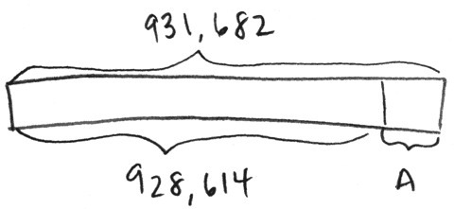
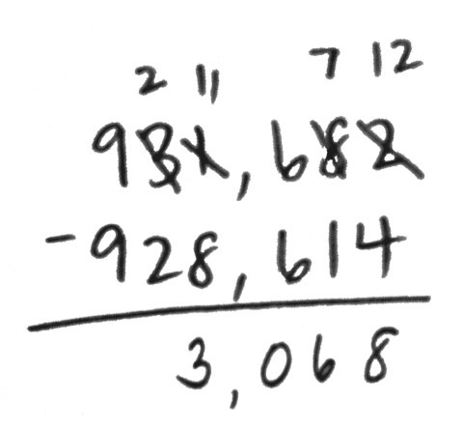
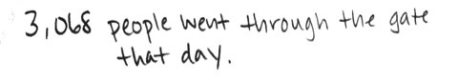
When the amusement park opened, the number on the counter at the gate read 928,614. At the end of the day, the counter read 931,682. How many people went through the gate that day?

Note: At times, we ask students to use a specific strategy, and at other times, we see what they do independently. This question engages students in MP.5 by leaving open the solution path.

Concept Development (32 minutes)
Materials: (T) Millions place value chart (Lesson 11) (S) Personal white board, millions place value chart (Lesson 11 Template)
Problem 1: Regroup units 5 times to subtract.
Write 253,421 – 75,832 vertically on the board.
T: Say this problem with me.
T: Work with your partner to draw a tape diagram representing this problem.
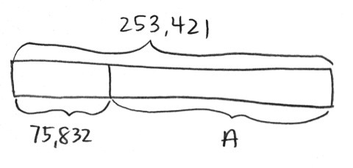
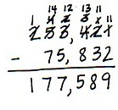

T: What is the whole amount?

NOTES ON
MULTIPLE MEANS
OF ENGAGEMENT:
Students of all abilities will benefit from using addition to check subtraction. Students should see that if the sum does not match the whole, the subtraction (or calculation) is faulty. They must subtract again and then check with addition. Challenge students to think about how they use this check strategy in everyday life. We use it all of the time when we add up to another number.

S: 253,421.
T: What is the part?
S: 75,832.
T: Look across the top number, 253,421, to see if we have enough units in each column to subtract 75,832.
Are we ready to subtract?
S: No!
T: Are there enough ones in the top number to subtract the ones in the bottom number? (Point to the 1 and 2 in the ones column.)
S: No, 1 one is less than 2 ones.
T: What should we do?
S: Change 1 ten for 10 ones. That means you have 1 ten and 11 ones.
T: Are there enough tens in the top number to subtract the tens in the bottom number? (Point to tens column.)
S: No, 1 ten is less than 3 tens.
T: What should we do?
S: Change 1 hundred for 10 tens. You have 3 hundreds and 11 tens.
T: The tens column is ready to subtract.
Have partners continue questioning if there are enough units to subtract in each column, regrouping where needed.
T: Are we ready to subtract?
S: Yes, we’re ready to subtract!
T: Go ahead and subtract. State the difference to your partner. Label the unknown part in your tape diagram.
S: The difference between 253,421 and 75,832 is 177,589. (Label A = 177,589.)
T: Add the difference to the part you knew to see if your answer is correct.
S: It is. The sum of the parts is 253,421.
Problem 2: Decompose numbers from 1 thousand and 1 million into smaller units to subtract, modeled with place value disks.
Write 1,000 – 528 vertically on the board.
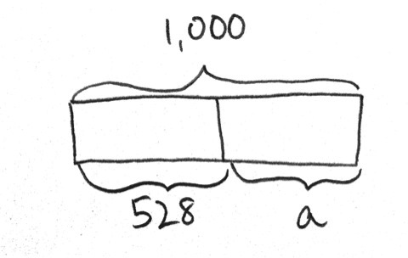
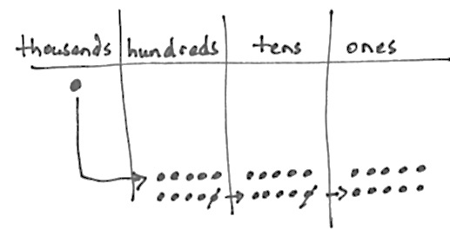
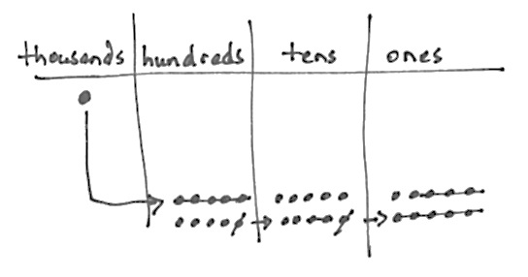
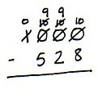
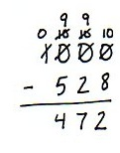
T: With your partner, read this problem and draw a tape diagram. Label what you know and the unknown.

MP.6

T: Record the problem on your personal white board.

NOTES ON
MULTIPLE MEANS
OF ACTION AND EXPRESSION:
Encourage students who notice a pattern of repeated nines when subtracting across multiple zeros to express this pattern in writing.
Allow students to identify why this happens using manipulatives and/or in writing. Allow students to slowly transition into recording this particular unbundling across zeros as nines as they become fluent with using the algorithm.

T: Look across the units in the top number. Are we ready to subtract?
S: No!
T: Are there enough ones in the top number to subtract the ones in the bottom number? (Point to 0 and 8 in the ones column.)
S: No. 0 ones is less than 8 ones.
T: I need to ungroup 1 unit from the tens. What do you notice?
S: There are no tens to ungroup.
T: We can look to the hundreds. (There are no hundreds to ungroup either.)
T: In order to get 10 ones, we need to regroup 1 thousand. Watch as I represent the ungrouping in my subtraction problem. (Model using place value disks and rename units in the problem simultaneously.) Now it’s your turn.
T: Are we ready to subtract?
S: Yes, we’re ready to subtract!
T: Solve for 9 hundreds 9 tens 10 ones minus 5 hundreds 2 tens 8 ones.
S: 1,000 – 528 is 472.
T: Check our answer.
S: The sum of 472 and 528 is 1000.
Write 1,000,000 – 345,528 vertically on the board.
T: Read this problem, and draw a tape diagram to represent the subtraction problem.
T: Record the subtraction problem on your board.
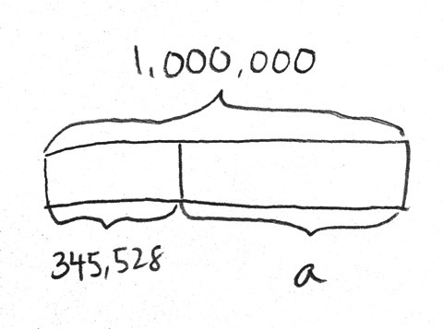
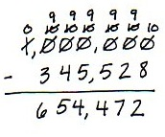
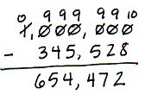
or

T: What do you notice when you look across the top number?
S: There are a lot more zeros. We will have to regroup 6 times. We are not ready to subtract.
We will have to regroup 1 million to solve the problem.
T: Work with your partner to get 1,000,000 ready to subtract. Rename your units in the subtraction problem.
S: 9 hundred thousands 9 ten thousands 9 thousands 9 hundreds 9 tens 10 ones. We are ready to subtract!
S: 1,000,000 minus 345,528 equals 654,472.
T: To check your answer, add the parts to see if you get the correct whole amount.
S: We did! We got one million when we added the parts.
Problem 3: Solve a word problem, decomposing units multiple times.
Last year, there were 620,073 people in attendance at a local parade. This year, there were 456,795 people in attendance. How many more people were in attendance last year?
T: Read with me.
T: Represent this information in a tape diagram.
T: Work with your partner to write a subtraction problem using the information in the tape diagram.
T: Look across the units in the top number. Are you ready to subtract?
S: No, I do not have enough ones in the top number. I need to unbundle 1 ten to make 10 ones. Then I have 6 tens and 13 ones.
T: Continue to check if you are ready to subtract in each column. When you are ready to subtract, solve.
S: 620,073 minus 456,795 equals 163,278. There were 163,278 more people in attendance last year.
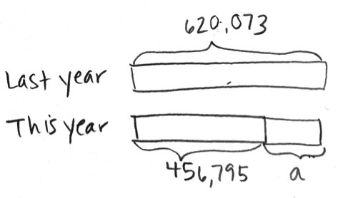
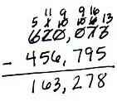

Problem Set (10 minutes)
Students should do their personal best to complete the Problem Set within the allotted 10 minutes. For some classes, it may be appropriate to modify the assignment by specifying which problems they work on first. Some problems do not specify a method for solving. Students should solve these problems using the RDW approach used for Application Problems.
Student Debrief (11 minutes)
Lesson Objective: Use place value understanding to fluently decompose to smaller units multiple times in any place using the standard subtraction algorithm, and apply the algorithm to solve word problems using tape diagrams.
The Student Debrief is intended to invite reflection and active processing of the total lesson experience.
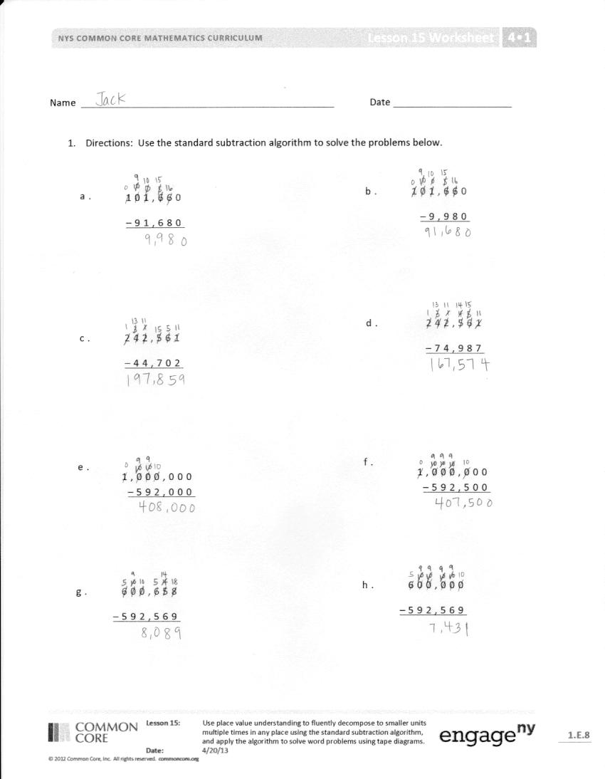
Invite students to review their solutions for the Problem Set. They should check work by comparing answers with a partner before going over answers as a class. Look for misconceptions or misunderstandings that can be addressed in the Debrief. Guide students in a conversation to debrief the Problem Set and process the lesson. You may choose to use any combination of the questions below to lead the discussion.
- Problems 1(e) and (f) were similar. Did anyone notice a pattern that could be used to solve these problems?
- How did your tape diagrams differ in Problems 2, 3, and 4?
- How do you know when you are ready to subtract across the problem?
- How can you check your answer when subtracting?
- Is there a number that you can subtract from 1,000,000 without decomposing across to the ones (other than 1,000,000)? 100,000? 10,000?
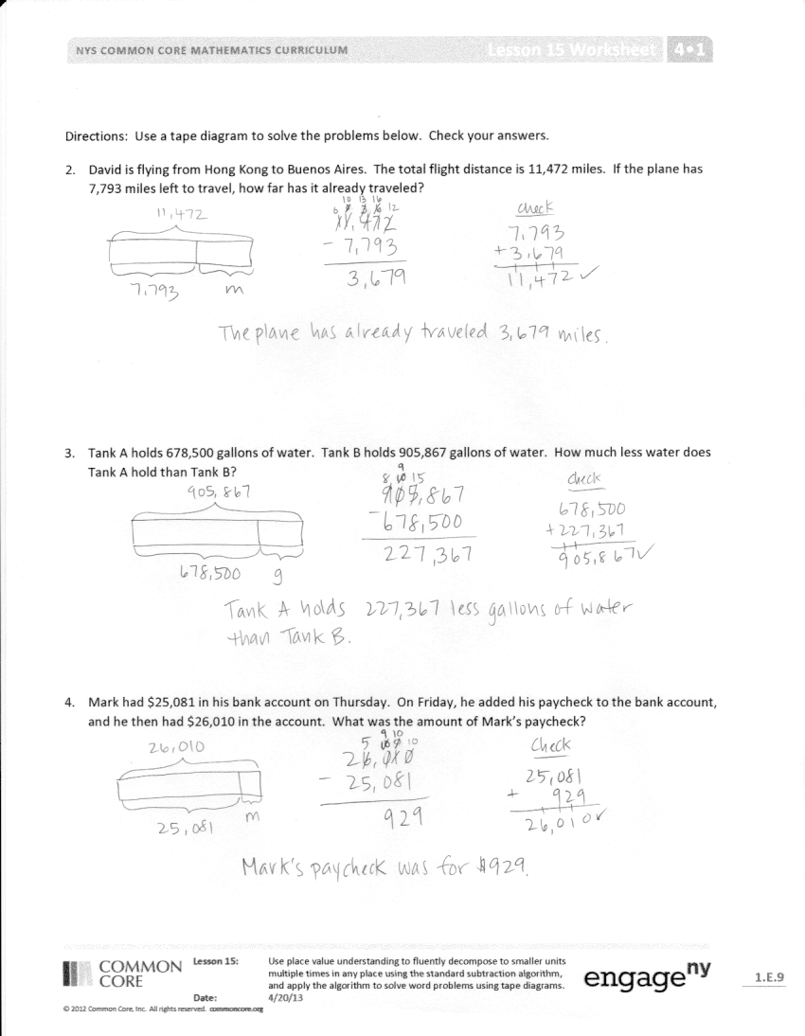
- How can decomposing multiple times be challenging?
- How does the tape diagram help you determine which operation to use to find the answer?
Exit Ticket (3 minutes)
After the Student Debrief, instruct students to complete the Exit Ticket. A review of their work will help you assess the students’ understanding of the concepts that were presented in the lesson today and plan more effectively for future lessons. You may read the questions aloud to the students.

Name Date

- Use the standard subtraction algorithm to solve the problems below.

a. |  | 1 | 0 | 1, | 6 | 6 | 0
 | − |  | 9 | 1, | 6 | 8 | 0
b. |  | 1 | 0 | 1, | 6 | 6 | 0
 | − |  |  | 9, | 9 | 8 | 0

c. |  | 2 | 4 | 2, | 5 | 6 | 1
 | − |  | 4 | 4, | 7 | 0 | 2
d. |  | 2 | 4 | 2, | 5 | 6 | 1
 | − |  | 7 | 4, | 9 | 8 | 7

e. |  | 1, | 0 | 0 | 0, | 0 | 0 | 0
 | − |  | 5 | 9 | 2, | 0 | 0 | 0

f. |  | 1, | 0 | 0 | 0, | 0 | 0 | 0
 | − |  | 5 | 9 | 2, | 5 | 0 | 0
h. |  | 6 | 0 | 0, | 0 | 0 | 0
 | − | 5 | 9 | 2, | 5 | 6 | 9

g. |  | 6 | 0 | 0, | 6 | 5 | 8
 | − | 5 | 9 | 2, | 5 | 6 | 9

Use tape diagrams and the standard algorithm to solve the problems below. Check your answers.
- David is flying from Hong Kong to Buenos Aires. The total flight distance is 11,472 miles. If the plane has 7,793 miles left to travel, how far has it already traveled?

- Tank A holds 678,500 gallons of water. Tank B holds 905,867 gallons of water. How much less water does Tank A hold than Tank B?

- Mark had $25,081 in his bank account on Thursday. On Friday, he added his paycheck to the bank account, and he then had $26,010 in the account. What was the amount of Mark’s paycheck?

Name Date
Draw a tape diagram to model each problem and solve.
- 956,204 – 780,169 =_______________

- A construction company was building a stone wall on Main Street. 100,000 stones were delivered to the site. On Monday, they used 15,631 stones. How many stones remain for the rest of the week? Write your answer as a statement.

Name Date

- Use the standard subtraction algorithm to solve the problems below.

b. | 59,656
 | - 5,880

c. | 759,656
 | - 579,989
a. | 9,656
 | - 838

e. | 294,150
 | - 239,089

d. | 294,150
 | - 166,370
f. | 294,150
 | - 96,400

i. | 800,500
 | - 276,664

h. | 800,500
 | - 45,500
g. | 800,500
 | - 79,989

Use tape diagrams and the standard algorithm to solve the problems below. Check your answers.
- A fishing boat was out to sea for 6 months and traveled a total of 8,578 miles. In the first month, the boat traveled 659 miles. How many miles did the fishing boat travel during the remaining 5 months?

- A national monument had 160,747 visitors during the first week of September. A total of 759,656 people visited the monument in September. How many people visited the monument in September after the first week?

- Shadow Software Company earned a total of $800,000 selling programs during the year 2012. $125,300 of that amount was used to pay expenses of the company. How much profit did Shadow Software Company make in the year 2012?

- At the local aquarium, Bubba the Seal ate 25,634 grams of fish during the week. If, on the first day of the week, he ate 6,987 grams of fish, how many grams of fish did he eat during the remainder of the week?

