Lesson 13
Objective: Use place value understanding to decompose to smaller units once using the standard subtraction algorithm and apply the algorithm to solve word problems using tape diagrams.

Suggested Lesson Structure
 Fluency Practice (12 minutes)
 Application Problem (5 minutes)
 Concept Development (35 minutes)
 Student Debrief (8 minutes)
Total Time (60 minutes)
Fluency Practice (12 minutes)
- Find the Sum 4.NBT.4 (6 minutes)
- Subtract Common Units 4.NBT.3 (6 minutes)
Find the Sum (6 minutes)
Materials: (S) Personal white board
Note: This math fluency activity prepares students for understanding the importance of the addition algorithm.
T: (Write 316 + 473 =____.) Solve by writing an addition sentence horizontally or vertically.
S: (Write 316 + 473 = 789.)
Repeat process and sequence for 6,065 + 3,731; 13,806 + 4,393; 5,928 + 124; and 629 + 296 + 962.
Subtract Common Units (6 minutes)
Materials: (S) Personal white board
Note: This mental math fluency activity prepares students for understanding the importance of the subtraction algorithm.
T: (Project 707.) Say the number in unit form.
S: 7 hundreds 7 ones.
T: (Write 707 – 202 =____.) Say the subtraction sentence and answer in unit form.
S: 7 hundreds 7 ones – 2 hundreds 2 ones = 5 hundreds 5 ones.
T: Write the subtraction sentence on your personal white boards.
S: (Write 707 – 202 = 505.)
Repeat process and sequence for 909 – 404; 9,009 – 5,005; 11,011 – 4,004; and 13,013 – 8,008.
Application Problem (5 minutes)
Jennifer texted 5,849 times in January. In February, she texted 1,263 more times than in January. What was the total number of texts that Jennifer sent in the two months combined? Explain how you know your answer is reasonable.
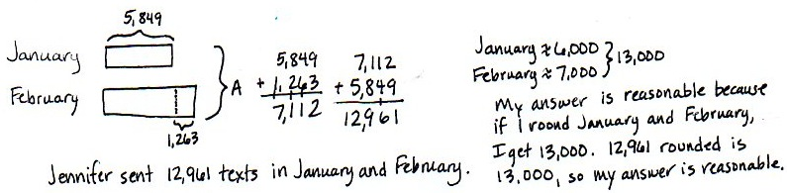

Note: This Application Problem reviews content from the previous lesson of a multi-step addition problem.
Concept Development (35 minutes)
Materials: (T) Millions place value chart (Lesson 11 Template) (S) Personal white board, millions place value chart template (Lesson 11 Template)
Problem 1: Use a place value chart and place value disks to model subtracting alongside the algorithm, regrouping 1 hundred into 10 tens.
Display 4,259 – 2,171 vertically on the board.
T: Say this problem with me. (Read problem together.)
T: Watch as I draw a tape diagram to represent this problem. What is the whole?
S: 4,259.
T: We record that above the tape as the whole and record the known part of 2,171 under the tape. It’s your turn to draw a tape diagram. Mark the unknown part of the diagram with the variable A.
T: Model the whole, 4,259, using place value disks on your place value chart.
T: Do we model the part we are subtracting?
S: No, just the whole.
T: First, let’s determine if we are ready to subtract. We look across the top number, from right to left, to see if there are enough units in each column. Let’s look at the ones column. Are there enough ones in the top number to subtract the ones in the bottom number? (Point to the 9 and the 1 in the problem.)
S: Yes, 9 is greater than 1.
T: That means we are ready to subtract in the ones column. Let’s look at the tens column. Are there enough tens in the top number to subtract the tens in the bottom number?
S: No, 5 is less than 7.
T: (Show regrouping on the place value chart.) We ungroup or unbundle 1 unit from the hundreds to make 10 tens. I now have 1 hundred and 15 tens. Let’s rename and represent the change in writing using the algorithm. (Cross out the hundreds and tens to rename them in the problem.)
MP.6
T: Show the change with your disks. (Cross off 1 hundred and change it for 10 tens as shown below.)
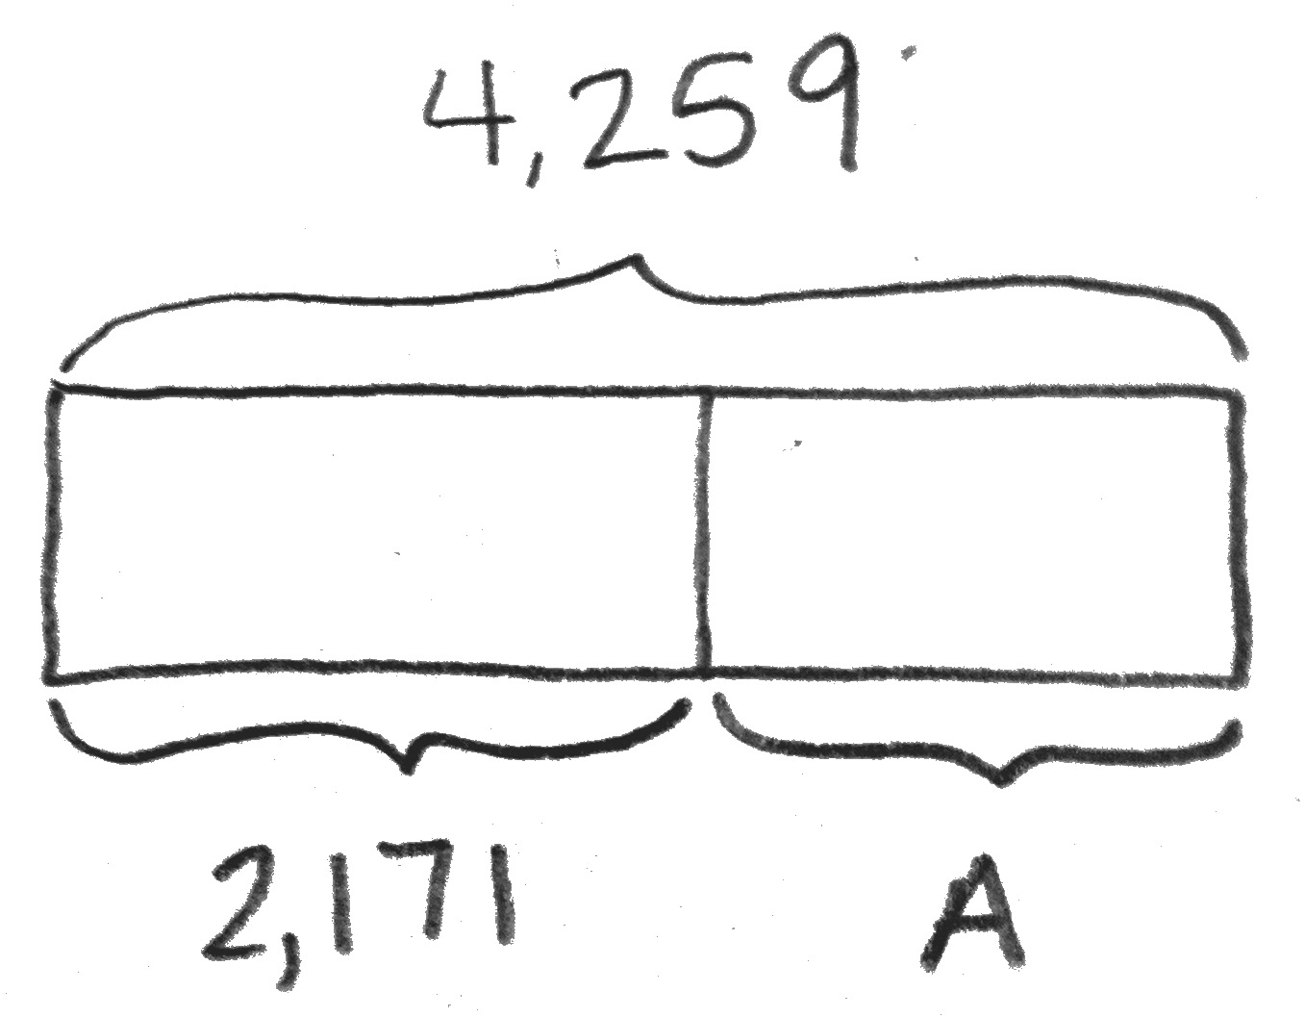
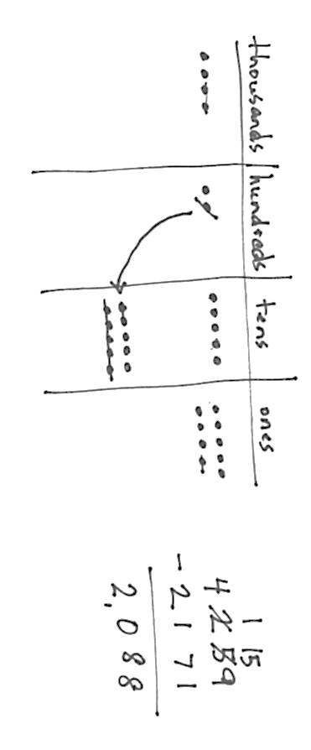

T: Are there enough hundreds in the top number to subtract the hundreds in the bottom number?
S: Yes, 1 is equal to 1.
T: Are there enough thousands in the top number to subtract the thousands in the bottom number?
S: Yes, 4 is greater than 2.
T: Are we ready to subtract?
S: Yes, we are ready to subtract!
T: (Point to the problem.) 9 ones minus 1 one?
S: 8 ones.
T: (Cross off 1 disk; write an 8 in the problem.)
T: 15 tens minus 7 tens?
S: 8 tens.
T: (Cross off 7 disks; write an 8 in the problem.)
Continue subtracting through the hundreds and thousands.
T: Say the number sentence.
S: 4,259 – 2,171 = 2,088.
T: The value of the A in our tape diagram is 2,088. We write A = 2,088 below the tape diagram.
What can be added to 2,171 to result in the sum of 4,259?
S: 2,088.
Repeat the process for 6,314 – 3,133.

Problem 2: Regroup 1 thousand into 10 hundreds using the subtraction algorithm.
Display 23,422 – 11,510 vertically on the board.
T: With your partner, read this problem and draw a tape diagram. Label the whole, the known part, and use the variable B for the unknown part.
T: Record the problem on your personal white board.
T: Look across the digits. Are we ready to subtract?
S: No!
T: Are there enough ones in the top number to subtract the ones in the bottom number? (Point to the 2 and the 0.)
S: Yes, 2 is greater than 0.
T: Are there enough tens in the top number to subtract the tens in the bottom number?
S: Yes, 2 is greater than 1.
T: Are there enough hundreds in the top number to subtract the hundreds in the bottom number?
S: No, 4 is less than 5.
T: Tell your partner how to make enough hundreds to subtract.
S: I unbundle 1 thousand to make 10 hundreds. I now have 2 thousands and 14 hundreds. I change 1 thousand for 10 hundreds. I rename 34 hundreds as 20 hundreds and 14 hundreds.
T: Watch as I record that. Now it’s your turn.
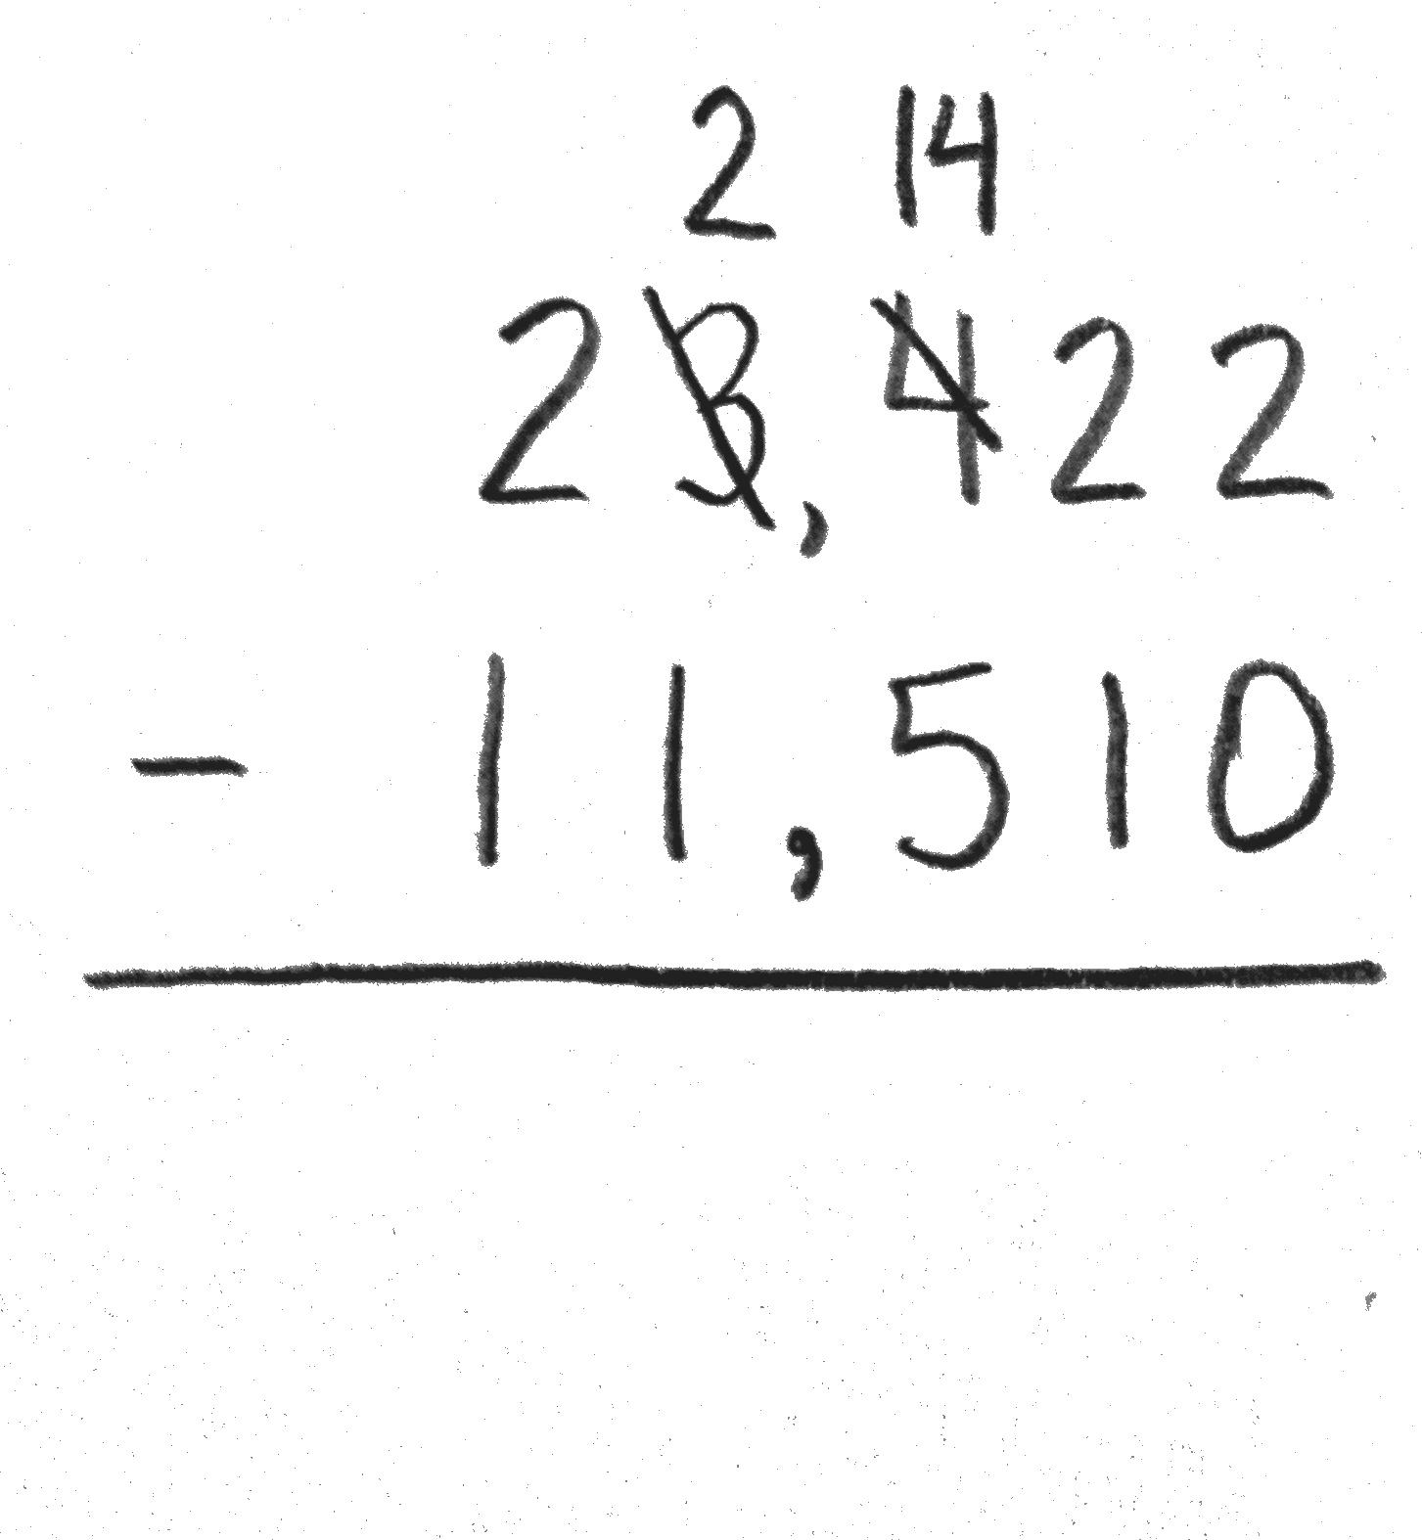
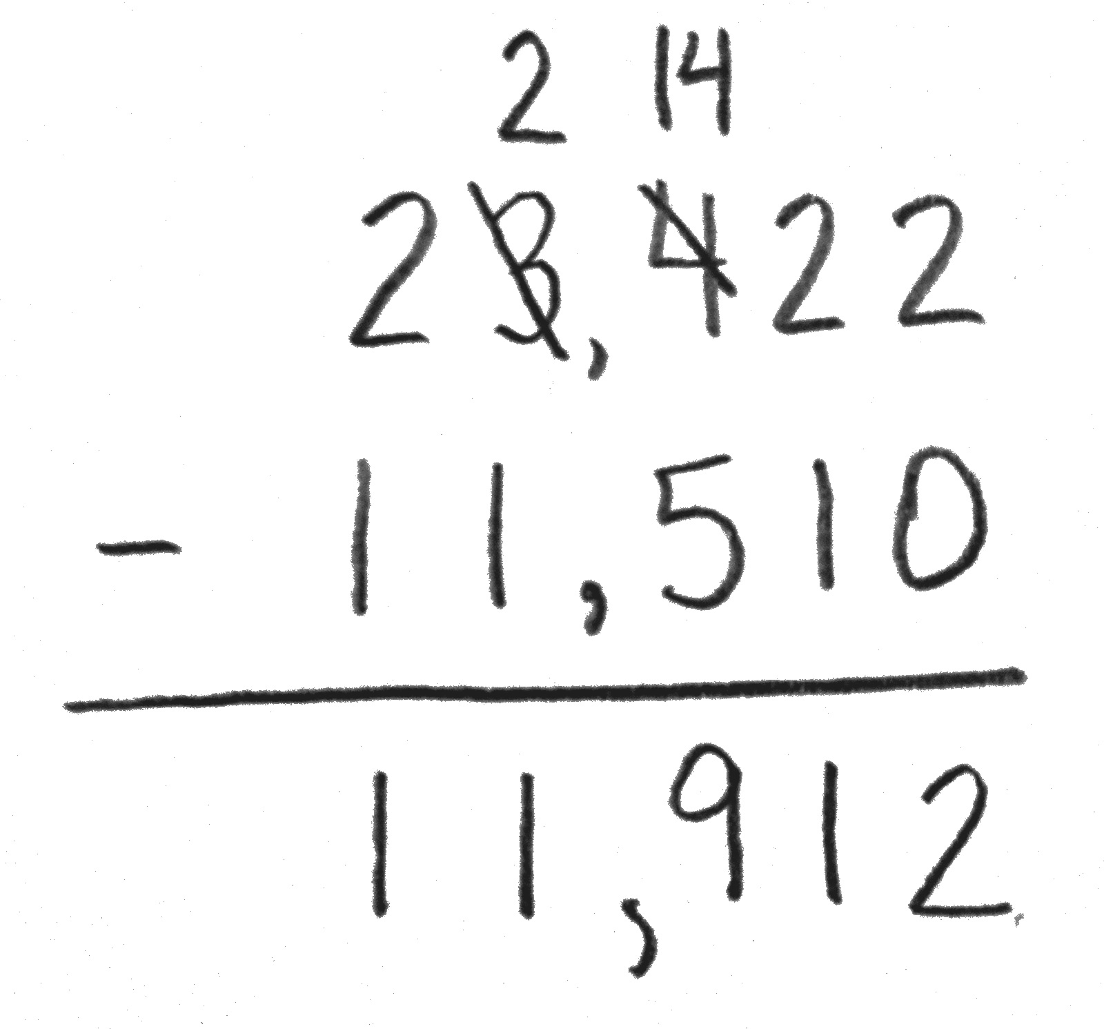
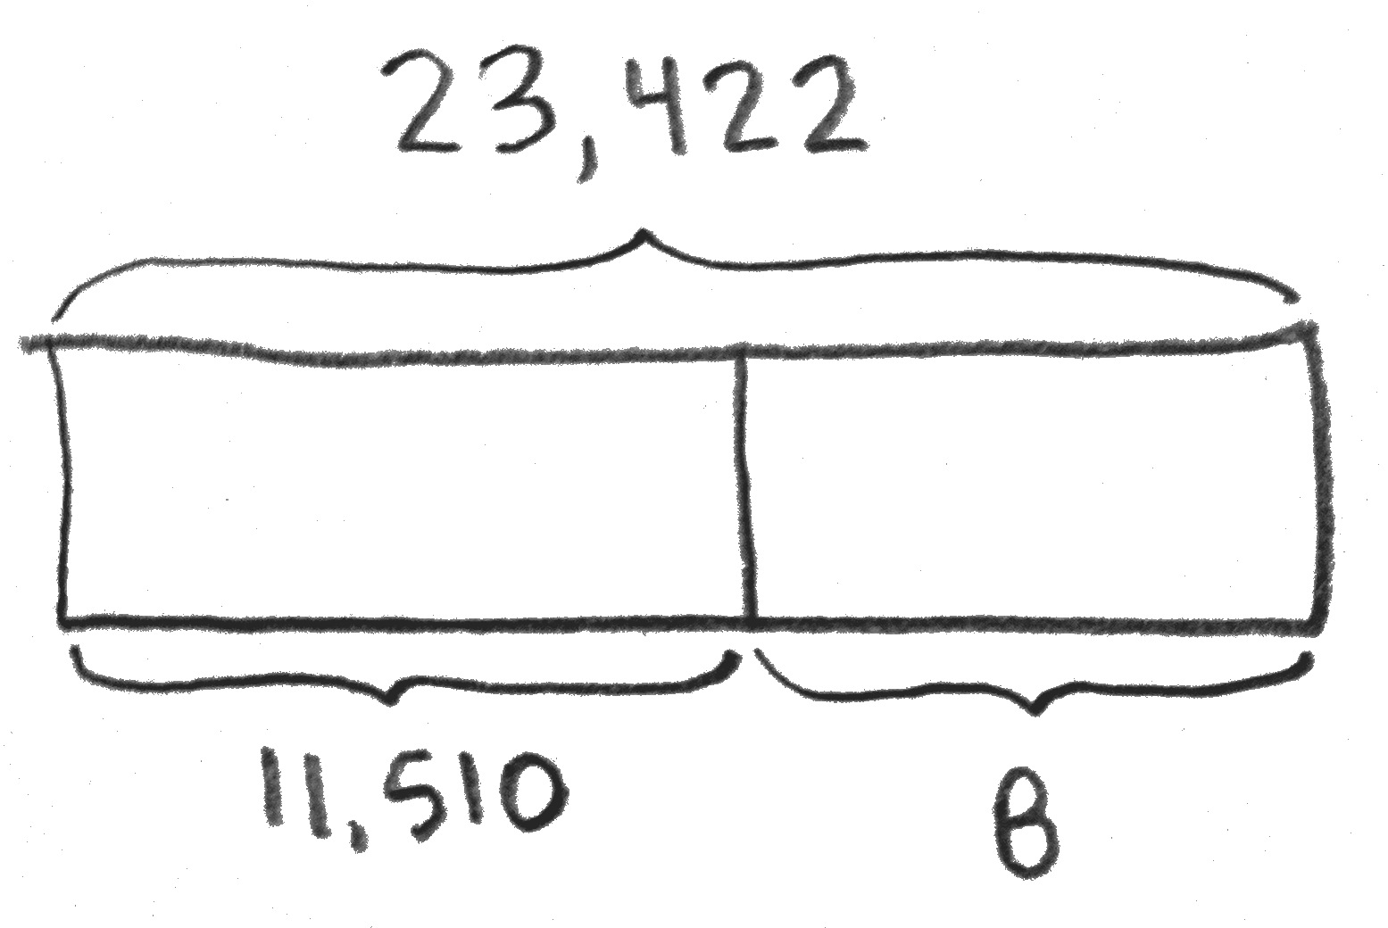

Repeat questioning for the thousands and ten thousands columns.
T: Are we ready to subtract?
S: Yes, we’re ready to subtract!
T: 2 ones minus 0 ones?
S: 2 ones. (Record 2 in the ones column.)
Continue subtracting across the number from right to left, always naming the units.
T: Tell your partner what must be added to 11,510 to result in the sum of 23,422.
T: How do we check a subtraction problem?
S: We can add the difference to the part we knew at first to see if the sum we get equals the whole.
T: Please add 11,912 and 11,510. What sum do you get?
S: 23,422, so our answer to the subtraction problem is correct.
T: Label your tape diagram as B = 11,912.
Repeat for 29,014 – 7,503.
Problem 3: Solve a subtraction word problem, regrouping 1 ten thousand into 10 thousands.
The paper mill produced 73,658 boxes of paper. 8,052 boxes have been sold. How many boxes remain?
T: Draw a tape diagram to represent the boxes of paper produced and sold. I’ll use the letter P to represent the boxes of paper remaining. Record the subtraction problem. Check to see that you lined up all units.

NOTES ON
MULTIPLE MEANS
OF ENGAGEMENT:
Ask students to look at the numbers in the subtraction problem and to think about how the numbers are related. Ask them how they might use their discovery to check to see if their answer is correct. Use the tape diagram to show if 8,052 was subtracted from 73,658 to find the unknown part of the tape diagram, the value of the unknown, 65,606, can be added to the known part of the tape diagram, 8,052. If the sum is the value of the whole tape diagram, the answer is correct.

T: Am I ready to subtract?
S: No!
T: Work with your partner, asking if there are enough units in each column to subtract. Regroup when needed. Then ask, “Am I ready to subtract?” before you begin subtracting. Use the standard algorithm. (Students work.)
S: 73,658 – 8,052 = 65,606.
T: The value of P is 65,606. In a statement, tell your partner how many boxes remain.
S: 65,606 boxes remain.
T: To check and see if your answer is correct, add the two values of the tape, 8,052 and your answer of 65,606, to see if the sum is the value of the tape, 73,658.
S: (Add to find that the sum matches the value of the tape.)
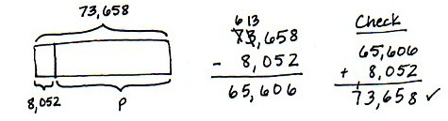

Repeat with the following: The library has 50,819 books. 4,506 are checked out. How many books remain in the library?

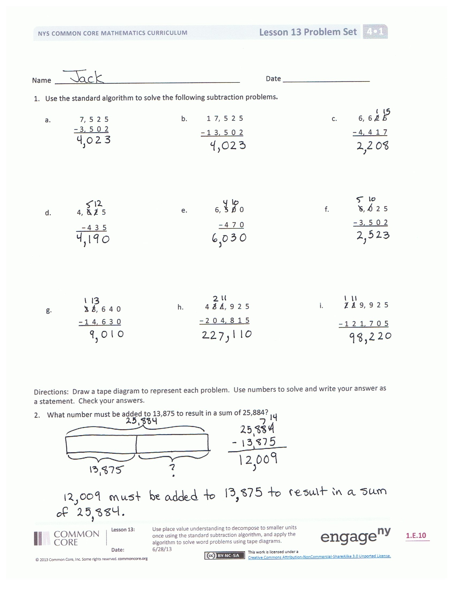
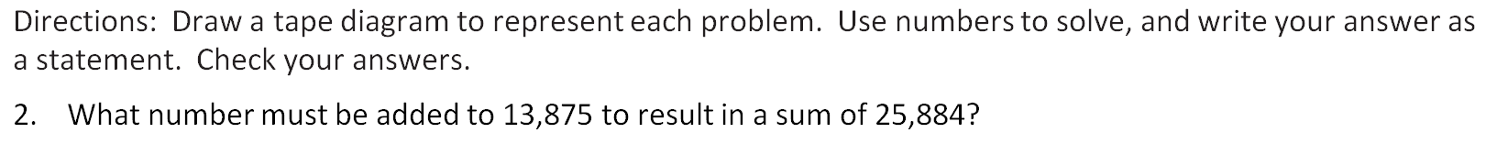
Problem Set (10 minutes)
Students should do their personal best to complete the Problem Set within the allotted 10 minutes. For some classes, it may be appropriate to modify the assignment by specifying which problems they work on first. Some problems do not specify a method for solving. Students should solve these problems using the RDW approach used for Application Problems.
Student Debrief (8 minutes)
Lesson Objective: Use place value understanding to decompose to smaller units once using the standard subtraction algorithm, and apply the algorithm to solve word problems using tape diagrams.
The Student Debrief is intended to invite reflection and active processing of the total lesson experience.
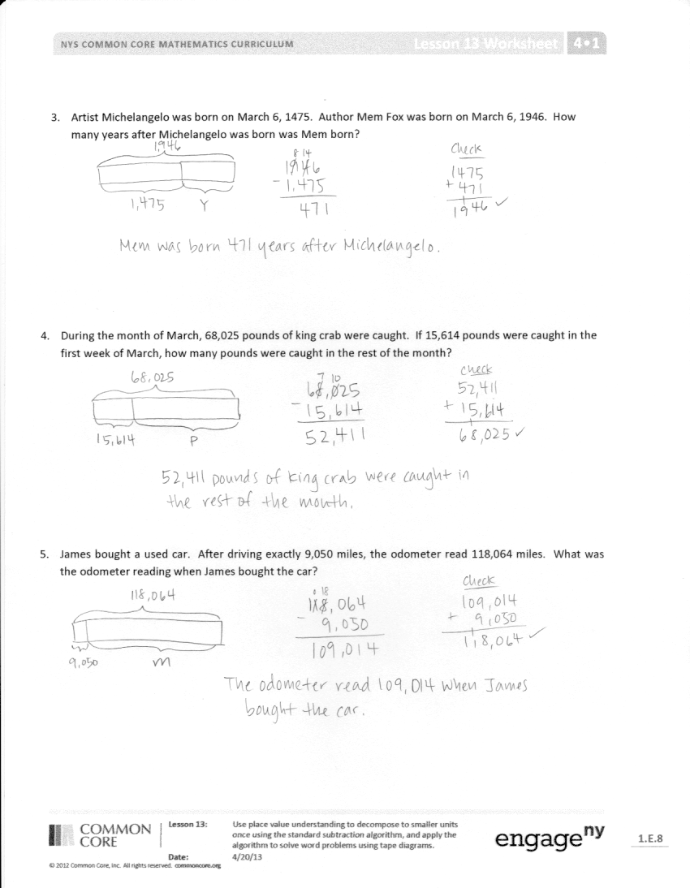
Invite students to review their solutions for the Problem Set. They should check work by comparing answers with a partner before going over answers as a class. Look for misconceptions or misunderstandings that can be addressed in the Debrief. Guide students in a conversation to debrief the Problem Set and process the lesson.
You may choose to use any combination of the questions below to lead the discussion.
- Compare your answers for Problem 1(a) and (b). How are your answers the same when the problems are different?
- Why do the days and months matter when solving Problem 3?
- Compare Problem 1(a) and (f). Does having a larger whole in 1(a) give an answer greater than or less than 1(f)?
- In Problem 4, you used subtraction, but I can say, “I can add 52,411 to 15,614 to result in the sum of 68,025.” How can we add and subtract using the same problem?
- Why do we ask, “Are we ready to subtract?”
- After we get our top number ready to subtract, do we have to subtract in order from right to left?
- When do we need to unbundle to subtract?
- What are the benefits to modeling subtraction using place value disks?
- Why must the units line up when subtracting? How might our answer change if the digits were not aligned?
- What happens when there is a zero in the top number of a subtraction problem?
- What happens when there is a zero in the bottom number of a subtraction problem?
- When you are completing word problems, how can you tell that you need to subtract?
Exit Ticket (3 minutes)
After the Student Debrief, instruct students to complete the Exit Ticket. A review of their work will help you assess the students’ understanding of the concepts that were presented in the lesson today and plan more effectively for future lessons. You may read the questions aloud to the students.

Name Date
- Use the standard algorithm to solve the following subtraction problems.

 | 7, 5 2 5 |  | 1 7, 5 2 5 |  | 6, 6 2 5
 | − 3, 5 0 2 |  | − 1 3, 5 0 2 |  | − 4, 4 1 7
 | 4, 6 2 5 |  | 6, 5 0 0 |  | 6, 0 2 5
 | − 4 3 5 |  | − 4 7 0 |  | − 3, 5 0 2
 | 2 3, 6 4 0 |  | 4 3 1, 9 2 5 |  | 2 1 9, 9 2 5
 | − 1 4, 6 3 0 |  | − 2 0 4, 8 1 5 |  | − 1 2 1, 7 0 5
Draw a tape diagram to represent each problem. Use numbers to solve, and write your answer as a statement. Check your answers.
- What number must be added to 13,875 to result in a sum of 25,884?

- Artist Michelangelo was born on March 6, 1475. Author Mem Fox was born on March 6, 1946.
How many years after Michelangelo was born was Mem born?

- During the month of March, 68,025 pounds of king crab were caught. If 15,614 pounds were caught in the first week of March, how many pounds were caught in the rest of the month?

- James bought a used car. After driving exactly 9,050 miles, the odometer read 118,064 miles. What was the odometer reading when James bought the car?

Name Date
- Use the standard algorithm to solve the following subtraction problems.
a. | 8, 5 1 2 |  | b. | 1 8, 0 4 2 |  | c. | 8, 0 7 2
 | – 2, 5 0 1 |  |  | – 4, 1 2 2 |  |  | – 1, 5 6 1

Draw a tape diagram to represent the following problem. Use numbers to solve. Write your answer as a statement. Check your answer.
2. What number must be added to 1,575 to result in a sum of 8,625?

Name Date
- Use the standard algorithm to solve the following subtraction problems.

 | 2,431 |  | 422,431 |  | 422,431
 | – 341 |  | – 14,321 |  | –92,420
 | 422,431 |  | 982,430 |  | 243,089
 | – 392,420 |  | –92,300 |  | – 137,079
 | 2,431 – 920 = |  |  |  | 892,431 – 520,800 =

- What number must be added to 14,056 to result in a sum of 38,773?

Draw a tape diagram to model each problem. Use numbers to solve, and write your answers as a statement. Check your answers.
- An elementary school collected 1,705 bottles for a recycling program. A high school also collected some bottles. Both schools collected 3,627 bottles combined. How many bottles did the high school collect?

- A computer shop sold $356,291 worth of computers and accessories. It sold $43,720 worth of accessories. How much did the computer shop sell in computers?

- The population of a city is 538,381. In that population, 148,170 are children.
  - How many adults live in the city?

  - 186,101 of the adults are males. How many adults are female?

