Lesson 11
Objective: Use place value understanding to fluently add multi-digit whole numbers using the standard addition algorithm, and apply the algorithm to solve word problems using tape diagrams.

Suggested Lesson Structure
 Fluency Practice (12 minutes)
 Application Problem (7 minutes)
 Concept Development (30 minutes)
 Student Debrief (11 minutes)
Total Time (60 minutes)
Fluency Practice (12 minutes)
- Round to Different Place Values 4.NBT.3 (5 minutes)
- Multiply by 10 3.NBT.3 (4 minutes)
- Add Common Units 3.NBT.2 (3 minutes)
Round to Different Place Values (5 minutes)
Materials: (S) Personal white board
Note: This fluency activity reviews rounding skills that are building towards mastery.
T: (Write 3,941.) Say the number. We are going to round this number to the nearest thousand.
T: How many thousands are in 3,941?
S: 3 thousands.
T: (Label the lower endpoint of a vertical number line with 3,000.) And 1 more thousand is?
S: 4 thousands.
T: (Mark the upper endpoint with 4,000.) Draw the same number line.
S: (Draw number line.)
T: What’s halfway between 3,000 and 4,000?
S: 3,500.
T: Label 3,500 on your number line as I do the same. Now, label 3,941 on your number line.
S: (Label 3,5000 and 3,941.)
T: Is 3,941 nearer to 3,000 or 4,000?
T: (Write 3,941 ≈ ____.) Write your answer on your personal white board.
S: (Write 3,941 ≈ 4,000.)
Repeat process for 3,941 rounded to the nearest hundred, 74,621 rounded to the nearest ten thousand and nearest thousand, and 681,904 rounded to the nearest hundred thousand, nearest ten thousand, and nearest thousand.
Multiply by 10 (4 minutes)
Materials: (S) Personal white board
Note: This fluency activity deepens student understanding of base ten units.
T: (Write 10 $\text{×}$ ____ = 100.) Say the multiplication sentence.
S: 10 $\text{×}$ 10 = 100.
T: (Write 10 $\text{×}$ 1 ten = ____.) On your personal white boards, fill in the blank.
S: (Write 10 $\text{×}$ 1 ten = 10 tens.)
T: (Write 10 tens = ____ hundred.) On your personal white boards, fill in the blank.
T: (Write ____ten $\text{×}$ ____ten = 1 hundred.) On your boards, fill in the blanks.
S: (Write 1 ten $\text{×}$ 1 ten = 1 hundred.)
Repeat process for the following possible sequence: 1 ten $\text{×}$ 60 = ____, 1 ten $\text{×}$ 30 = ____ hundreds,
1 ten $\text{×}$ ____ = 900, and 7 tens $\text{×}$ 1 ten = ____ hundreds.
Note: Watch for students who say 3 tens $\text{×}$ 4 tens is 12 tens rather than 12 hundreds.
Add Common Units (3 minutes)
Materials: (S) Personal white board
Note: This mental math fluency activity prepares students for understanding the importance of the algorithm.
T: (Project 303.) Say the number in unit form.
S: 3 hundreds 3 ones.
T: (Write 303 + 202 = ____.) Say the addition sentence and answer in unit form.
S: 3 hundreds 3 ones + 2 hundreds 2 ones = 5 hundreds 5 ones.
T: Write the addition sentence on your personal white boards.
S: (Write 303 + 202 = 505.)
Repeat process and sequence for 505 + 404; 5,005 + 5,004; 7,007 + 4,004; and 8,008 + 5,005.
Application Problem (7 minutes)

NOTES ON
MULTIPLE MEANS
OF REPRESENTATION:
For the Application Problem, students working below grade level may need further guidance in putting together three addends. Help them to break it down by putting two addends together and then adding the third addend to the total. Use manipulatives to demonstrate.

Meredith kept track of the calories she consumed for 3 weeks. The first week, she consumed 12,490 calories, the second week 14,295 calories, and the third week 11,116 calories. About how many calories did Meredith consume altogether? Which of these estimates will produce a more accurate answer: rounding to the nearest thousand or rounding to the nearest ten thousand? Explain.

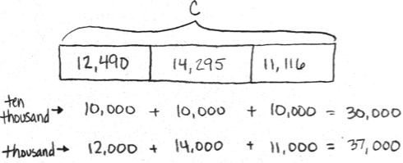
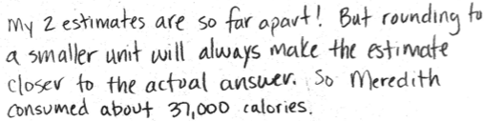

Note: This problem reviews rounding from Lesson 10 and can be used as an extension after the Debrief to support the objective of this lesson.
Concept Development (30 minutes)
Materials: (T) Millions place value chart (Template) (S) Personal white board, millions place value chart (Template)
Note: Using the template provided within this lesson in upcoming lessons provides students with space to draw a tape diagram and record an addition or a subtraction problem below the place value chart. Alternatively, the unlabeled millions place value chart template from Lesson 2 could be used along with paper and pencil.
Problem 1: Add, renaming once, using place value disks in a place value chart.
T: (Project vertically: 3,134 + 2,493.) Say this problem with me.
S: Three thousand, one hundred thirty-four plus two thousand, four hundred ninety-three.
T: Draw a tape diagram to represent this problem. What are the two parts that make up the whole?
S: 3,134 and 2,493.
T: Record that in the tape diagram.
T: What is the unknown?
S: In this case, the unknown is the whole.
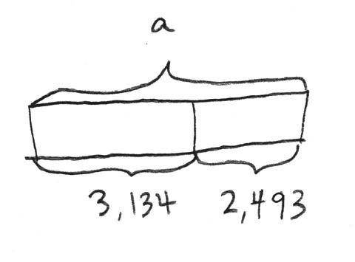
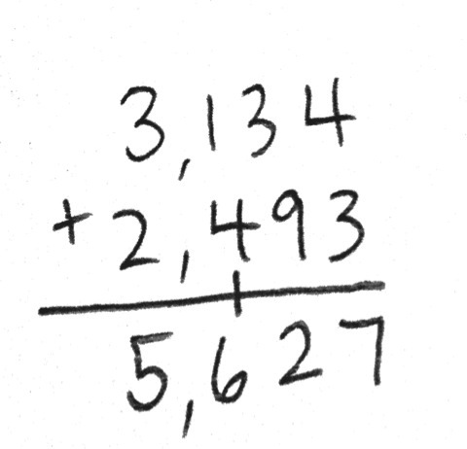
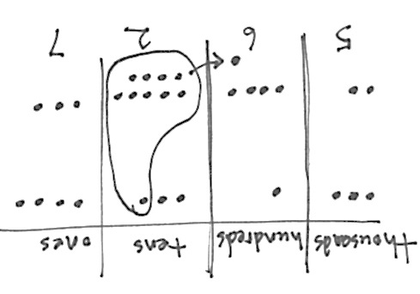

T: Show the whole above the tape diagram using a bracket and label the unknown quantity with an a. When a letter represents an unknown number, we call that letter a variable.
T: (Draw place value disks on the place value chart to represent the first part, 3,134.) Now, it’s your turn. When you are done, add 2,493 by drawing more disks on your place value chart.
T: (Point to the problem.) 4 ones plus 3 ones equals?
S: 7 ones. (Count 7 ones in the chart, and record 7 ones in the problem.)
T: (Point to the problem.) 3 tens plus 9 tens equals?
S: 12 tens. (Count 12 tens in the chart.)
T: We can bundle 10 tens as 1 hundred. (Circle 10 ten disks, draw an arrow to the hundreds place, and draw the 1 hundred disk to show the regrouping.)
MP.1
T: We can represent this in writing. (Write 12 tens as 1 hundred, crossing the line, and 2 tens in the tens column so that you are writing 12 and not 2 and 1 as separate numbers. Refer to the visual above.)
T: (Point to the problem.) 1 hundred plus 4 hundreds plus 1 hundred equals?
S: 6 hundreds. (Count 6 hundreds in the chart, and record 6 hundreds in the problem.)
T: (Point to the problem.) 3 thousands plus 2 thousands equals?
S: 5 thousands. (Count 5 thousands in the chart, and record 5 thousands in the problem.)
T: Say the equation with me: 3,134 plus 2,493 equals 5,627. Label the whole in the tape diagram, above the bracket, with a = 5,627.
Problem 2: Add, renaming in multiple units, using the standard algorithm and the place value chart.
T: (Project vertically: 40,762 + 30,473.) With your partner, draw a tape diagram to model this problem, labeling the two known parts and the unknown whole, using the variable B to represent the whole. (Circulate and assist students.)
T: With your partner, write the problem and draw disks for the first addend in your chart. Then, draw disks for the second addend.
T: (Point to the problem.) 2 ones plus 3 ones equals?
S: 5 ones. (Count the disks to confirm 5 ones, and write 5 in the ones column.)
T: 6 tens plus 7 tens equals?

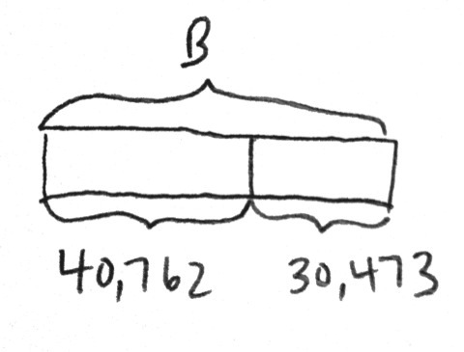
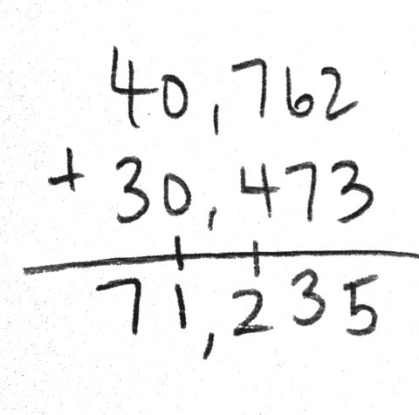
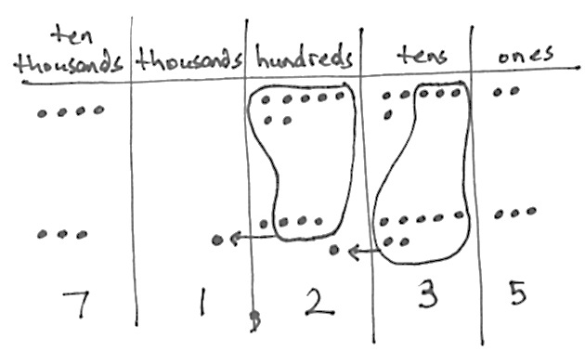

S: 13 tens. We can group 10 tens to make 1 hundred. We don’t write two digits in one column. We can change 10 tens for 1 hundred leaving us with 3 tens.
T: (Regroup the disks.) Watch me as I record the larger unit using the addition problem. (First, record the 1 on the line in the hundreds place, and then record the 3 in the tens so that you are writing 13, not 3 then 1.)
T: 7 hundreds plus 4 hundreds plus 1 hundred equals 12 hundreds. Discuss with your partner how to record this. (Continue adding, regrouping, and recording across other units.)
T: Say the equation with me. 40,762 plus 30,473 equals 71,235. Label the whole in the tape diagram with 71,235, and write B = 71,235.
Problem 3: Add, renaming multiple units using the standard algorithm.
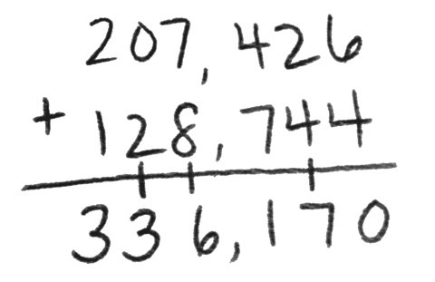
T: (Project: 207,426 + 128,744.) Draw a tape diagram to model this problem. Record the numbers on your personal white board.
T: With your partner, add units right to left, regrouping when necessary using the standard algorithm.
S: 207,426 + 128,744 = 336,170.
Problem 4: Solve a one-step word problem using the standard algorithm modeled with a tape diagram.
The Lane family took a road trip. During the first week, they drove 907 miles. The second week they drove the same amount as the first week plus an additional 297 miles. How many miles did they drive during the second week?
T: What information do we know?
S: We know they drove 907 miles the first week.
We also know they drove 297 miles more during the second week than the first week.
T: What is the unknown information?
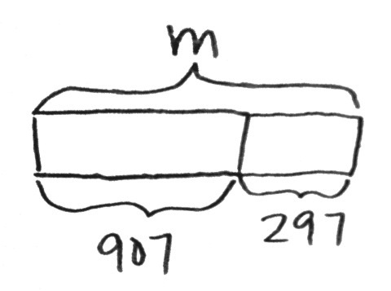
S: We don’t know the total miles they drove in the second week.
T: Draw a tape diagram to represent the amount of miles in the first week, 907 miles. Since the Lane family drove an additional 297 miles in the second week, extend the bar for 297 more miles. What does the tape diagram represent?
S: The number of miles they drove in the second week.

NOTES ON
MULTIPLE MEANS
OF ACTION
AND EXPRESSION:
English language learners benefit from further explanation of the word problem. Have a conversation around the following: “What do we do if we don’t understand a word in the problem? What thinking can we use to figure out the answer anyway?”
In this case, students do not need to know what a road trip is in order to solve. Discuss, “How is the tape diagram helpful to us?” It may be helpful to use the RDW approach: Read important information. Draw a picture. Write an equation to solve. Write the answer as a statement.
T: Use a bracket and label the unknown with the variable m for miles.
T: How do we solve for m?
S: 907 + 297 = m.
T: (Check student work to see they are recording the regrouping of 10 of a smaller unit for 1 larger unit.)
T: Solve. What is m?
S: m = 1,204. (Write m = 1,204.)
T: Write a statement that tells your answer.
S: (Write: The Lane family drove 1,204 miles during the second week.)
Problem Set (10 minutes)
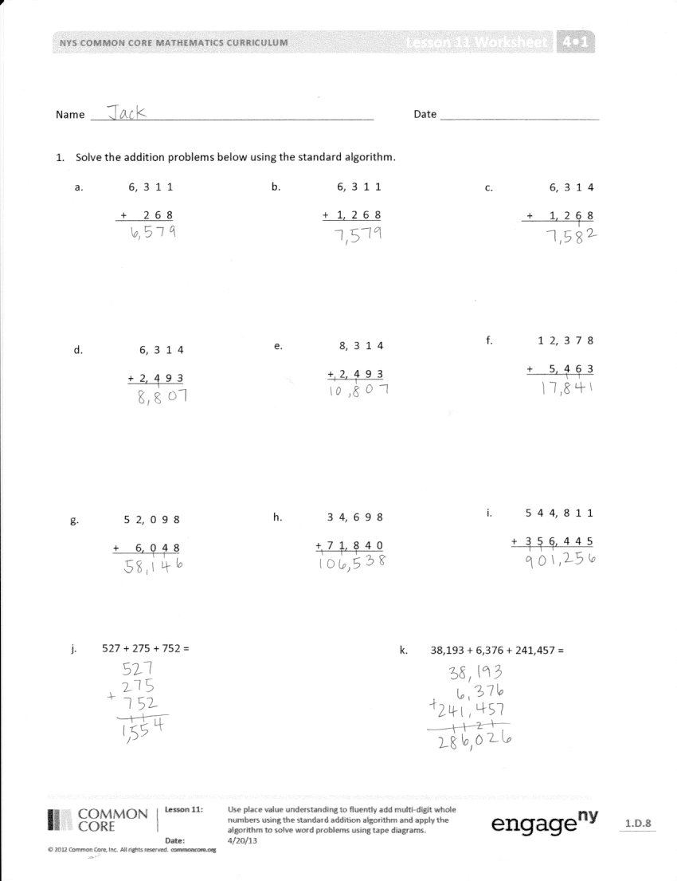
Students should do their personal best to complete the Problem Set within the allotted 10 minutes. For some classes, it may be appropriate to modify the assignment by specifying which problems they work on first. Some problems do not specify a method for solving. Students should solve these problems using the RDW approach used for Application Problems.
Student Debrief (11 minutes)
Lesson Objective: Use place value understanding to fluently add multi-digit whole numbers using the standard addition algorithm, and apply the algorithm to solve word problems using tape diagrams.
Invite students to review their solutions for the Problem Set and the totality of the lesson experience. They should check work by comparing answers with a partner before going over answers as a class. Look for misconceptions or misunderstandings that can be addressed in the Debrief. Guide students in a conversation to debrief the Problem Set.
You may choose to use any combination of the questions below to lead the discussion.
- When we are writing a sentence to express our answer, what part of the original problem helps us to tell our answer using the correct words and context?
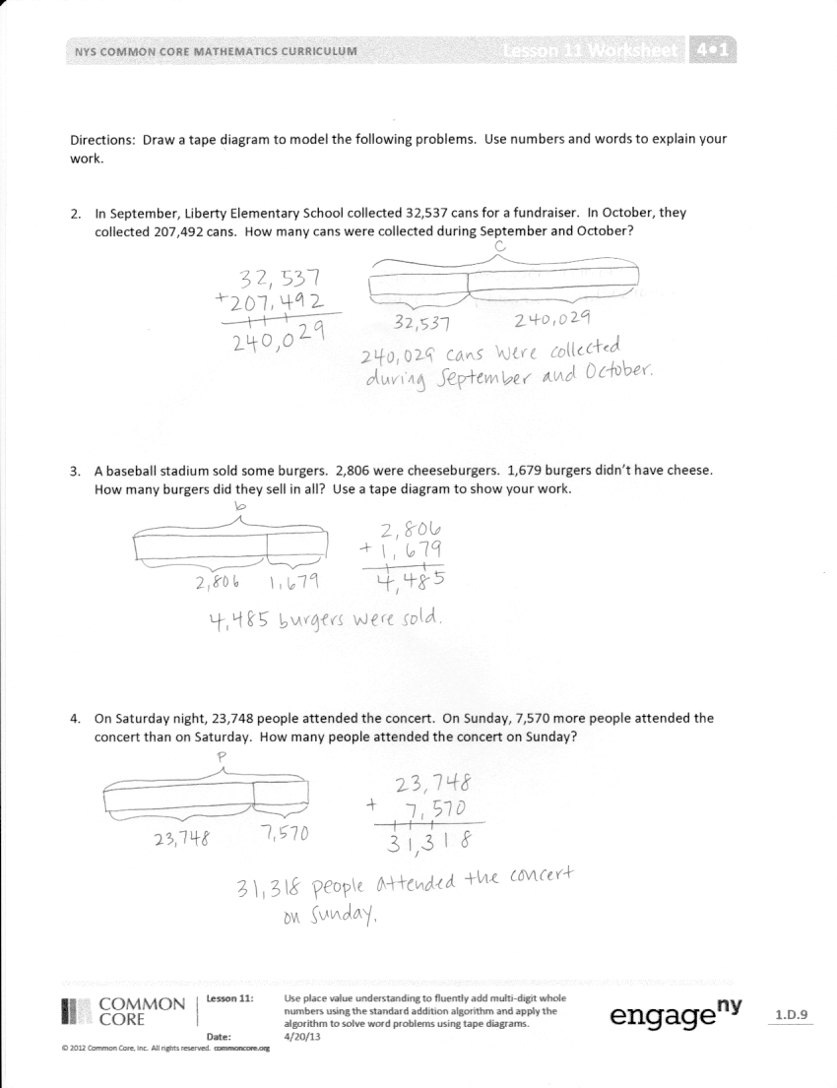
- What purpose does a tape diagram have? How does it support your work?
- What does a variable, like the letter C in Problem 2, help us do when drawing a tape diagram?
- I see different types of tape diagrams drawn for Problem 3. Some drew one bar with two parts. Some drew one bar for each addend and put the bracket for the whole on the right side of both bars. Will these diagrams result in different answers? Explain.
- In Problem 1, what did you notice was similar and different about the addends and the sums for Parts (a), (b), and (c)?
- If you have 2 addends, can you ever have enough ones to make 2 tens, or enough tens to make 2 hundreds, or enough hundreds to make 2 thousands? Try it out with your partner. What if you have 3 addends?
- In Problem 1(j), each addend used the numbers 2, 5, and 7 once. I don’t see those digits in the sum. Why?
- How is recording the regrouped number in the next column when using the standard algorithm related to bundling disks?
- Have students revisit the Application Problem and solve for the actual amount of calories consumed. Which unit, when rounding, provided an estimate closer to the actual value?
Exit Ticket (3 minutes)
After the Student Debrief, instruct students to complete the Exit Ticket. A review of their work will help you assess the students’ understanding of the concepts that were presented in the lesson today and plan more effectively for future lessons. You may read the questions aloud to the students.

Name Date

- Solve the addition problems below using the standard algorithm.

c. | 6, 3 1 4
 | + 1, 2 6 8
a. | 6, 3 1 1
 | + 2 6 8
b. | 6, 3 1 1
 | + 1, 2 6 8

e. | 8, 3 1 4
 | + 2, 4 9 3
d. | 6, 3 1 4
 | + 2, 4 9 3
f. | 1 2, 3 7 8
 | + 5, 4 6 3

g. | 5 2, 0 9 8
 | + 6, 0 4 8
h. | 3 4, 6 9 8
 | + 7 1, 8 4 0
i. | 5 4 4, 8 1 1
 | + 3 5 6, 4 4 5

k. | 38,193 + 6,376 + 241,457
j. | 527 + 275 + 752

Draw a tape diagram to represent each problem. Use numbers to solve, and write your answer as a statement.

- In September, Liberty Elementary School collected 32,537 cans for a fundraiser. In October, they collected 207,492 cans. How many cans were collected during September and October?

- A baseball stadium sold some burgers. 2,806 were cheeseburgers. 1,679 burgers didn’t have cheese. How many burgers did they sell in all?

- On Saturday night, 23,748 people attended the concert. On Sunday, 7,570 more people attended the concert than on Saturday. How many people attended the concert on Sunday?

Name Date

- Solve the addition problems below using the standard algorithm.

- 2 3, 6 0 7 b. 3, 9 4 8 c. 5,983 + 2,097
+ 2, 3 0 7 + 2 7 8

2. The office supply closet had 25,473 large paperclips, 13,648 medium paperclips, and 15,306 small paperclips. How many paperclips were in the closet?

Name Date

- Solve the addition problems below using the standard algorithm.

a. | 7,909
 | + 1,044
b. | 27,909
 | + 9,740
c. | 827,909
 | + 42,989

f. | 258,983
 | + 121,897

e. | 547,982
 | + 114,849
d. | 289,205
 | + 11,845

h. | 289,999
 | + 91,849
g. | 83,906
 | + 35,808
i. | 754,900
 | + 245,100

Draw a tape diagram to represent each problem. Use numbers to solve, and write your answer as a statement.
- At the zoo, Brooke learned that one of the rhinos weighs 4,897 pounds, one of the giraffes weighs 2,667 pounds, one of the African elephants weighs 12,456 pounds, and one of the Komodo dragons weighs 123 pounds.

  - What is the combined weight of the zoo’s African elephant and the giraffe?

  - What is the combined weight of the zoo’s African elephant and the rhino?

  - What is the combined weight of the zoo’s African elephant, the rhino, and the giraffe?

  - What is the combined weight of the zoo’s Komodo dragon and the rhino?

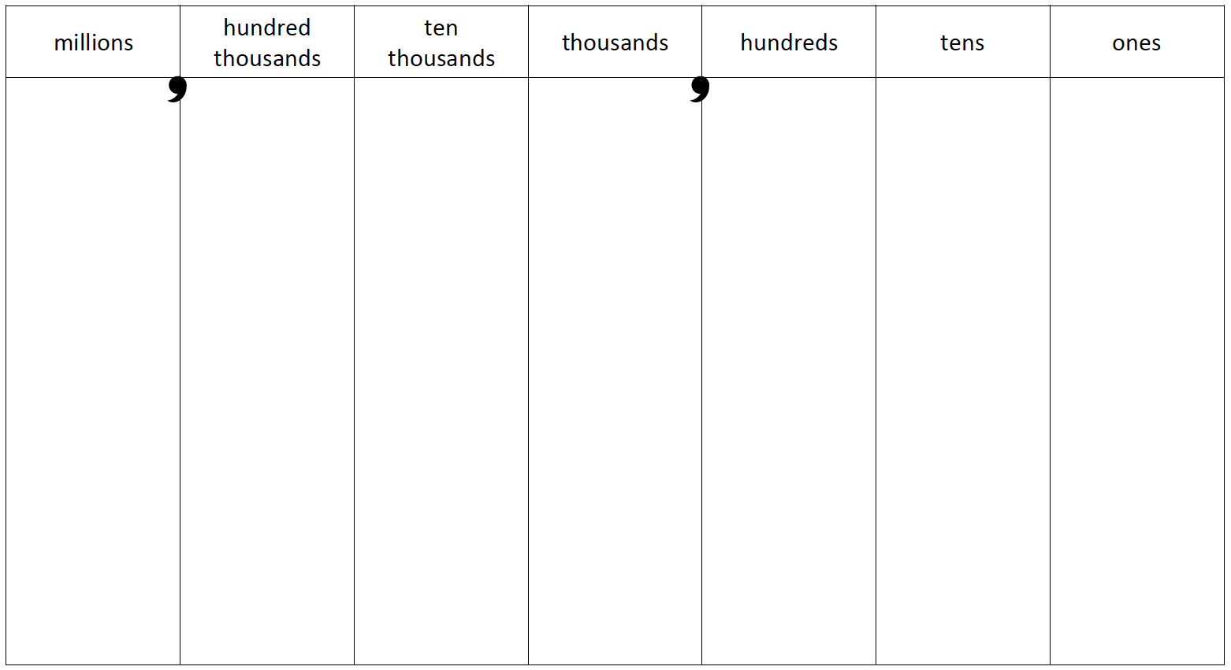

millions place value chart

