Lesson 9
Objective: Use place value understanding to round multi-digit numbers to any place value.

Suggested Lesson Structure
 Fluency Practice (12 minutes)
 Application Problem (8 minutes)
 Concept Development (30 minutes)
 Student Debrief (10 minutes)
Total Time (60 minutes)
Fluency Practice (12 minutes)
- Multiply by Ten 4.NBT.1 (5 minutes)
- Round to Different Place Values 4.NBT.3 (7 minutes)
Multiply by Ten (5 minutes)
Materials: (S) Personal white board
Note: This fluency activity deepens the students’ foundation of multiplying by ten.
T: (Write 10 × 10 =____.) Say the multiplication sentence.
S: 10 × 10 = 100.
T: (Write 10 × ____ ten = 100.) On your personal white boards, fill in the blank.
S: (Write 10 × 1 ten = 100.)
T: (Write ____ ten × ____ ten = 100.) On your boards, fill in the blanks.
S: (Write 1 ten × 1 ten = 100.)
T: (Write ____ ten × ____ ten = ____hundred.) On your boards, fill in the blanks.
S: (Write 1 ten × 1 ten = 1 hundred.)
Repeat process for possible sequence: 1 ten × 20 =____, 1 ten × 40 = ____ hundreds, 1 ten × ____= 700, and
4 tens × 1 ten = ____ hundreds.
Note: The use of the digit or a unit is intentional. It builds understanding of multiplying by different units
(6 ones times 1 ten equals 6 tens, so 6 tens times 1 ten equals 6 hundreds, not 6 tens).
Round to Different Place Values (7 minutes)
Materials: (S) Personal white board
Note: This fluency activity reviews Lesson 8’s objective and lays a foundation for today’s lesson.
T: (Write 63,941.) Say the number.
S: 63,941.
T: Round 63,941 to the nearest ten thousand. Between what 2 ten thousands is 63,941?
S: 6 ten thousands and 7 ten thousands.
T: On your boards, draw a vertical number line with 60,000 and 70,000 as endpoints.
S: (Draw a vertical number line with 60,000 and 70,000 as the endpoints.)
T: What’s halfway between 60,000 and 70,000?
S: 65,000.
T: Label 65,000 as the midpoint on your number line. Label 63,941 on your number line.
S: (Label 63,941 below 65,000 on their number lines.)
T: (Write 63,941 ≈ ____.) On your boards, fill in the blank, rounding 63,941 to the nearest ten thousand.
S: (Write 63,941 ≈ 60,000.)
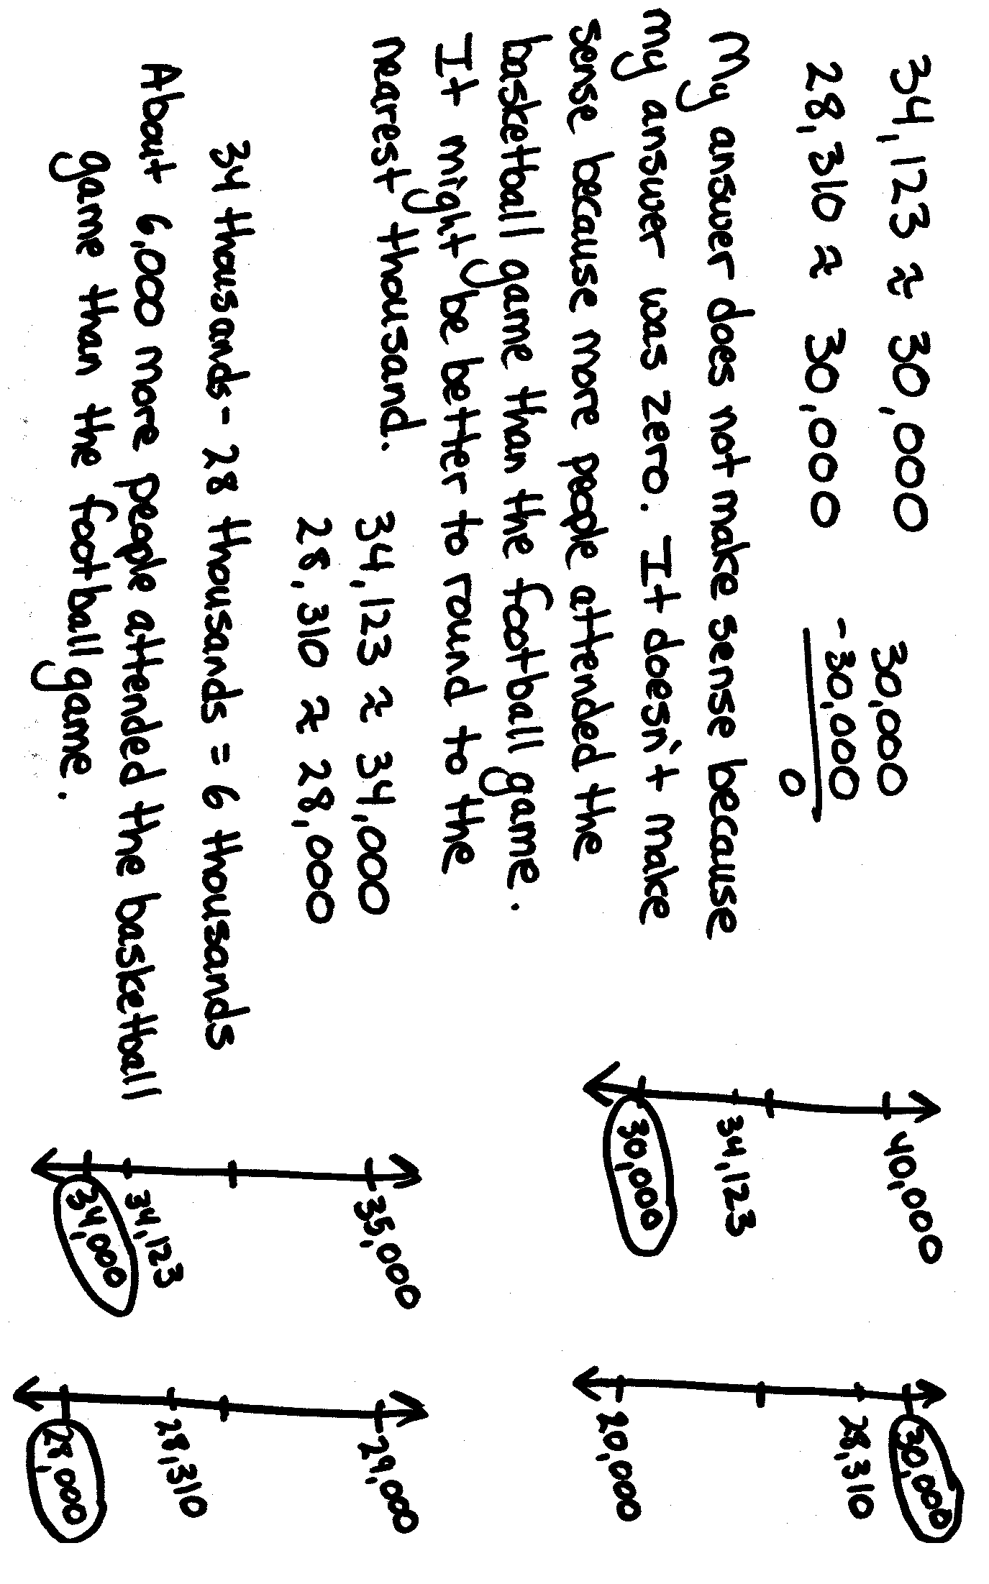
Repeat process for 63,941 rounded to the nearest thousand, 47,261 rounded to the nearest ten thousand, 47,261 rounded to the nearest thousand, 618,409 rounded to the nearest hundred thousand, 618,409 rounded to the nearest ten thousand, and 618,904 rounded to the nearest thousand.
Application Problem (8 minutes)
34,123 people attended a basketball game. 28,310 people attended a football game. About how many more people attended the basketball game than the football game? Round to the nearest ten thousand to find the answer. Does your answer make sense? What might be a better way to compare attendance?
Note: The Application Problem builds on the concept learned in the previous lesson (4.NBT.3) and on 3.NBT.2. Students are required to round and then to subtract using base thousand units. Students have not practiced an algorithm for subtracting with five digits. Due to the rounded numbers, you may show subtraction using unit form as an alternative method (34 thousand – 28 thousand, instead of 34,000 – 28,000).
Concept Development (30 minutes)
Materials: (S) Personal white board
Problem 1: Rounding to the nearest thousand without using a number line.
T: (Write 4,333 ≈ ____.) Round to the nearest thousand. Between what two thousands is 4,333?
S: 4 thousands and 5 thousands.
T: What is halfway between 4,000 and 5,000?
S: 4,500.
T: Is 4,333 less than or more than halfway?
S: Less than.

NOTES ON
MULTIPLE MEANS
OF REPRESENTATION:
Students who have difficulty visualizing 4,333 as having 4 thousands 3 hundreds could benefit from writing the number on their place value chart. In doing so, they will be able to see that 4,333 has 43 hundreds. This same strategy could also be used for other numbers.

T: So 4,333 is nearer to 4,000.
T: (Write 18,753 ≈____.) Round to the nearest thousand. Tell your partner between
what two thousands 18,753 is located.
S: 18 thousands and 19 thousands.
T: What is halfway between 18 thousands and 19 thousands?
S: 18,500.
T: Round 18,753 to the nearest thousand. Tell your partner if 18,753 is more than or less than halfway.
S: 18,753 is more than halfway. 18,753 is nearer to 19,000. 18,753 rounded to the nearest thousand
is 19,000.
Repeat with 346,560 rounded to the nearest thousand.
Problem 2: Rounding to the nearest ten thousand or hundred thousand without using a vertical line.
T: (Write 65,600 ≈ ____.) Round to the nearest ten thousand. Between what two ten thousands is 65,600?
S: 6 ten thousands and 7 ten thousands.
T: What is halfway between 60,000 and 70,000?
S: 65,000.
T: Is 65,600 less than or more than halfway?
S: 65,600 is more than halfway.
T: Tell your partner what 65,600 is when rounded to the nearest ten thousand.
S: 65,600 rounded to the nearest ten thousand is 70,000.
Repeat with 548,253 rounded to the nearest ten thousand.

T: (Write 676,000 ≈____.) Round 676,000 to the nearest hundred thousand. First tell your partner what your endpoints will be.
S: 600,000 and 700,000.
T: Determine the halfway point.
S: 650,000.
T: Is 676,000 more than or less than the halfway point?
S: More than.
T: Tell your partner what 676,000 is when rounded to the nearest hundred thousand.
S: 676,000 rounded to the nearest hundred thousand is 700,000.
T: (Write 203,301 ≈____.) Work with your partner to round 203,301 to the nearest hundred thousand.
T: Explain to your partner how we use the midpoint to round without a number line.
S: We can’t look at a number line, so we have to use mental math to find our endpoints and halfway point. If we know the midpoint, we can see if the number is greater than or less than the midpoint. When rounding, the midpoint helps determine which endpoint the rounded number is closer to.
Problem 3: Rounding to any value without using a number line.
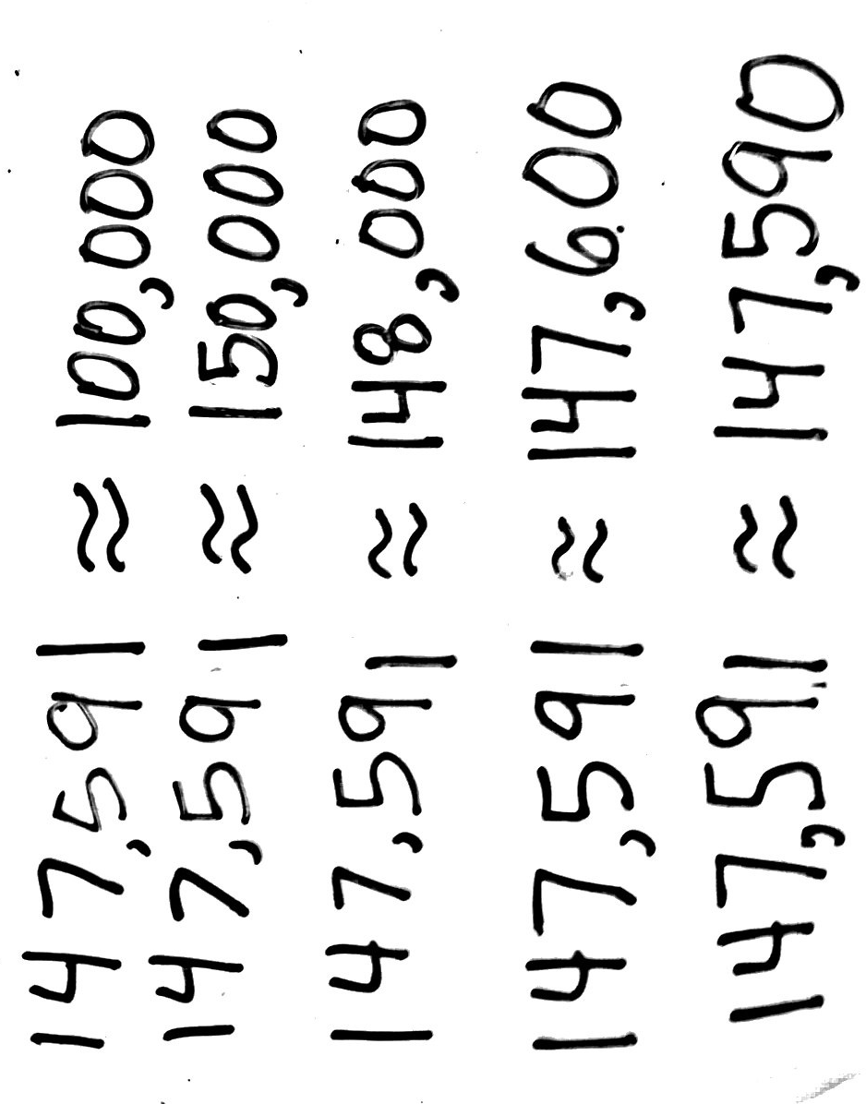
T: (Write 147,591 ≈____.) Whisper read this number to your partner in standard form. Now, round 147,591 to the nearest hundred thousand.
S: 100,000.
T: Excellent. (Write 147,591 ≈ 100,000. Point to 100,000.)
100,000 has zero ones in the ones place, zero tens in the tens place, zero hundreds in the hundreds place, zero thousands in the thousands place, and zero ten thousands in the ten thousands place. I could add, subtract, multiply, or divide with this rounded number much easier than with 147,591. True? But, what if I wanted a more accurate estimate? Give me a number closer to 147,591 that has (point) a zero in the ones, tens, hundreds, and thousands.

NOTES ON
MULTIPLE MEANS
OF ENGAGEMENT:
Challenge students who are above grade level to look at the many ways that they rounded the number 147,591 to different place values. Have them discuss with a partner what they notice about the rounded numbers. Students should notice that when rounding to the hundred thousands, the answer is 100,000, but when rounding to all of the other places, the answers are closer to 150,000. Have them discuss what this can teach them about rounding.

S: 150,000.
T: Why not 140,000?
S: 147,591 is closer to 150,000 because it is greater than the halfway point 145,000.
T: Great. 147,591 rounded to the nearest ten thousand is 150,000. Now let’s round 147,591 to the nearest thousand.
S: 148,000.
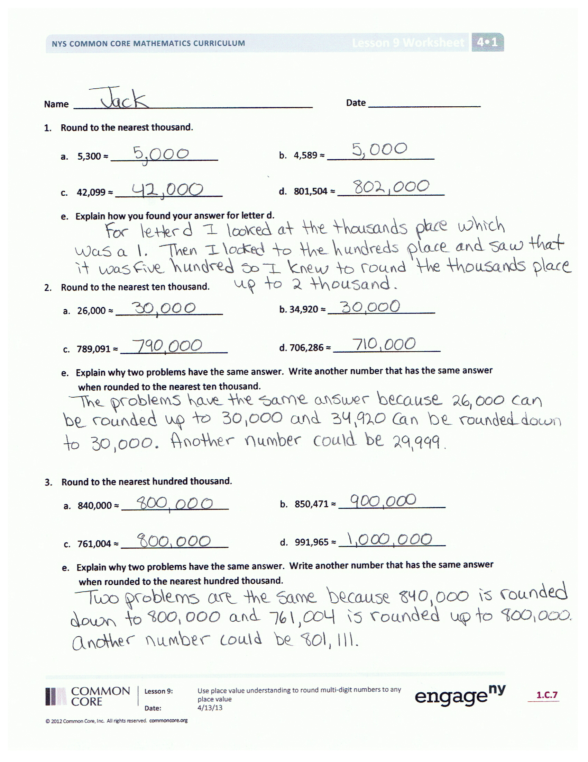
T: Work with your partner to round 147,591 to the nearest hundred and then the nearest ten.
S: 147,591 rounded to the nearest hundred is 147,600. 147,591 rounded to the nearest ten is 147,590.
MP.3
T: Compare estimates of 147,591 after rounding to different units. What do you notice? When might it be better to round to a larger unit? When might it be better to round to a smaller unit?
S: (Discuss.)
Problem Set (10 minutes)
Students should do their personal best to complete the Problem Set within the allotted 10 minutes. For some classes, it may be appropriate to modify the assignment by specifying which problems they work on first. Some problems do not specify a method for solving. Students should solve these problems using the RDW approach used for Application Problems.
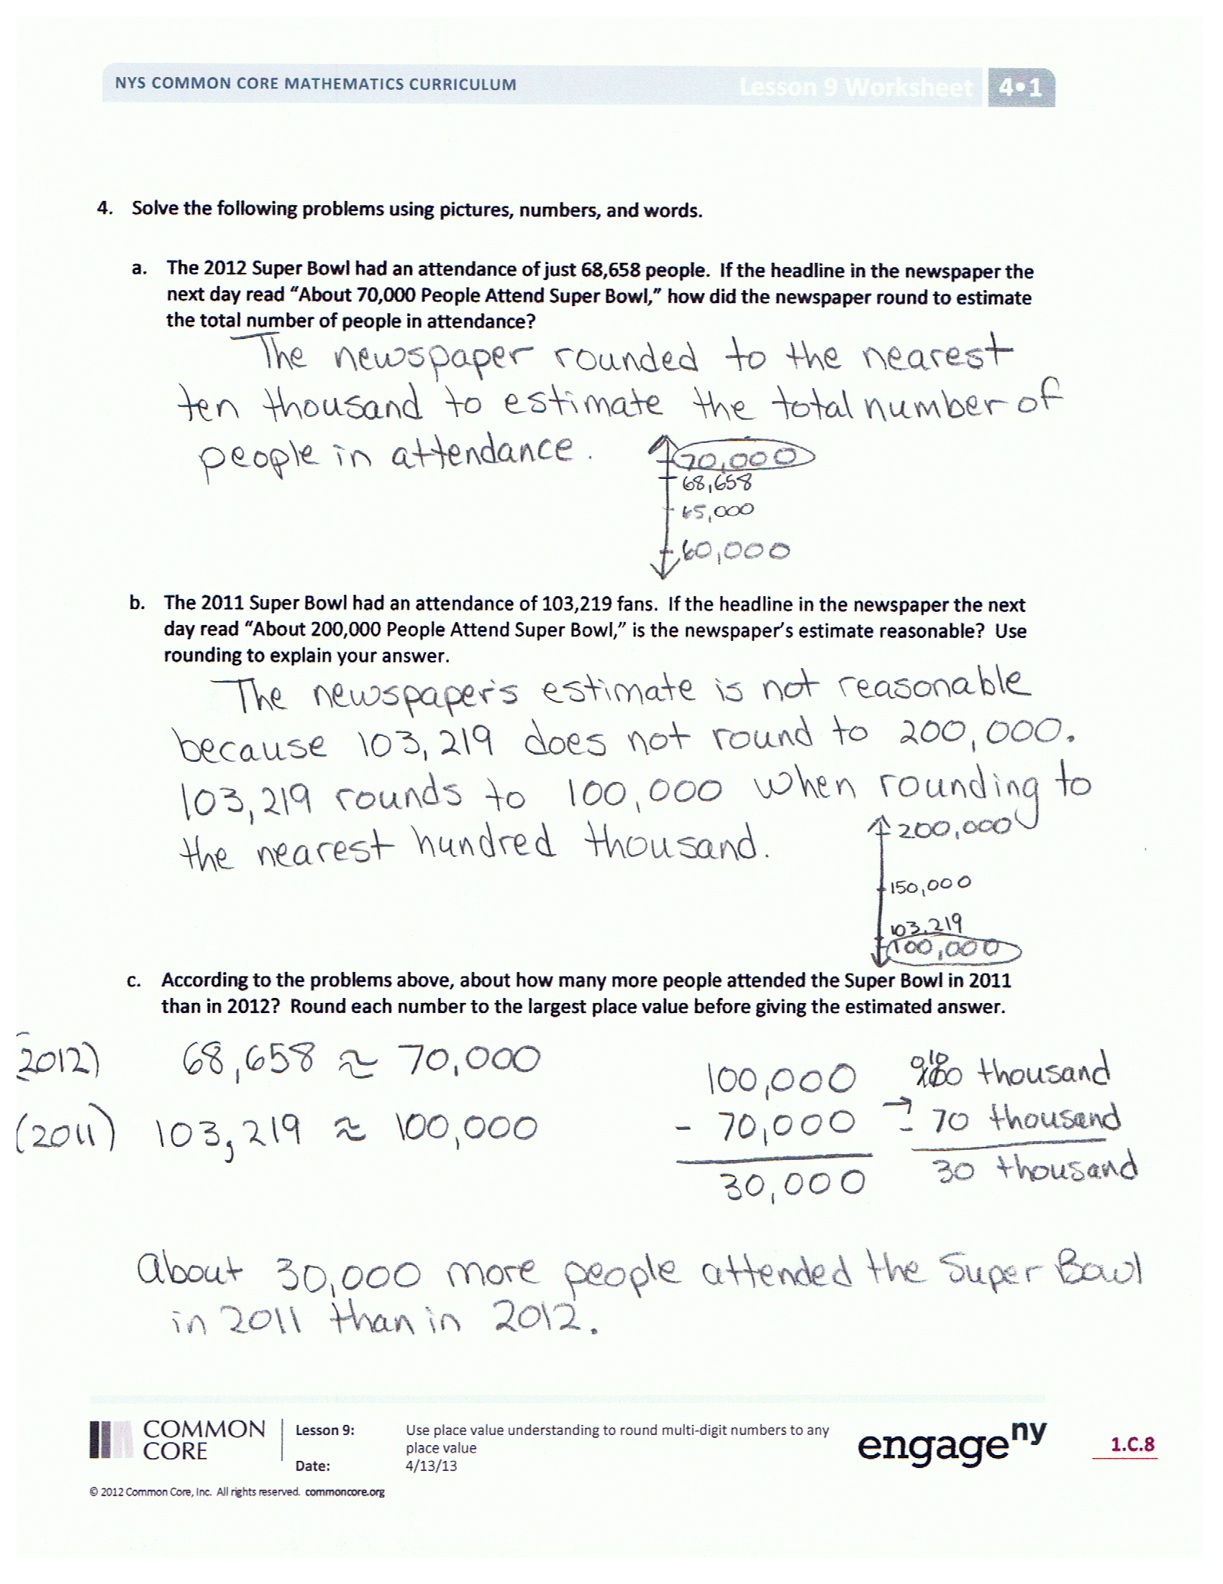
Student Debrief (10 minutes)
Lesson Objective: Use place value understanding to round multi-digit numbers to any place value.
Invite students to review their solutions for the Problem Set and the totality of the lesson experience. They should check work by comparing answers with a partner before going over answers as a class. Look for misconceptions or misunderstandings that can be addressed in the Debrief. Guide students in a conversation to debrief the Problem Set.
You may choose to use any combination of the questions below to lead the discussion.
- Explain the reasoning behind your answer for Problem 2(e) and Problem 3(e).
- In Problem 2(e), you and your partner probably wrote different numbers that rounded to 30,000. Explain why your numbers were different. What is the smallest possible number that could round to 30,000 when rounded to the nearest ten thousand? What is the largest possible number that could round to 30,000 when rounded to the nearest ten thousand? Explain your reasoning. (Use Problem 3(e) for further discussion.)
- Was there any difficulty in solving Problem 3(d)? Explain your strategy when solving this problem.
- In Problem 4(b), the newspaper rounded to the nearest hundred thousand inappropriately. What unit should the newspaper have rounded to and why?
- How is rounding without a number line easier? How is it more challenging?
- How does knowing how to round mentally assist you in everyday life?
- What strategy do you use when observing a number to be rounded?
Exit Ticket (3 minutes)
After the Student Debrief, instruct students to complete the Exit Ticket. A review of their work will help you assess the students’ understanding of the concepts that were presented in the lesson today and plan more effectively for future lessons. You may read the questions aloud to the students.

Name Date
- Round to the nearest thousand.
- 5,300 ≈ ______________________ b. 4,589 ≈ _____________________

c. 42,099 ≈ _____________________ d. 801,504 ≈ _____________________
e. Explain how you found your answer for Part (d).

- Round to the nearest ten thousand.
a. 26,000 ≈ _____________________ b. 34,920 ≈ _____________________
c. 789,091 ≈ _____________________ d. 706,286 ≈ _____________________
e. Explain why two problems have the same answer. Write another number that has the same answer when rounded to the nearest ten thousand.

- Round to the nearest hundred thousand.
a. 840,000 ≈ _____________________ b. 850,471 ≈ _____________________
c. 761,004 ≈ _____________________ d. 991,965 ≈ _____________________
e. Explain why two problems have the same answer. Write another number that has the same answer when rounded to the nearest hundred thousand.

- Solve the following problems using pictures, numbers, or words.
- The 2012 Super Bowl had an attendance of just 68,658 people. If the headline in the newspaper the next day read “About 70,000 People Attend Super Bowl,” how did the newspaper round to estimate the total number of people in attendance?

- The 2011 Super Bowl had an attendance of 103,219 people. If the headline in the newspaper the next day read “About 200,000 People Attend Super Bowl,” is the newspaper’s estimate reasonable? Use rounding to explain your answer.

- According to the problems above, about how many more people attended the Super Bowl in 2011 than in 2012? Round each number to the largest place value before giving the estimated answer.

Name Date

- Round 765,903 to the given place value:
Thousand __________________
Ten thousand __________________
Hundred thousand __________________

- There are 16,850 Star coffee shops around the world. Round the number of shops to the nearest thousand and ten thousand. Which answer is more accurate? Explain your thinking using pictures, numbers, or words.

Name Date
- Round to the nearest thousand.
- 6,842 ≈ _____________________ b. 2,722 ≈ _____________________

c. 16,051 ≈ _____________________ d. 706,421 ≈ _____________________
e. Explain how you found your answer for Part (d).

- Round to the nearest ten thousand.
- 88,999 ≈ _____________________ b. 85,001 ≈ _____________________

- 789,091 ≈ _____________________ d. 905,154 ≈ _____________________
e. Explain why two problems have the same answer. Write another number that has the same answer when rounded to the nearest ten thousand.

- Round to the nearest hundred thousand.
- 89,659 ≈ _____________________ b. 751,447 ≈ _____________________

- 617,889 ≈ _____________________ d. 817,245 ≈ _____________________

- Explain why two problems have the same answer. Write another number that has the same answer when rounded to the nearest hundred thousand.

- Solve the following problems using pictures, numbers, or words.
- At President Obama’s inauguration in 2013, the newspaper headlines stated there were about 800,000 people in attendance. If the newspaper rounded to the nearest hundred thousand, what is the largest number and smallest number of people that could have been there?

- At President Bush’s inauguration in 2005, the newspaper headlines stated there were about 400,000 people in attendance. If the newspaper rounded to the nearest ten thousand, what is the largest number and smallest number of people that could have been there?

- At President Lincoln’s inauguration in 1861, the newspaper headlines stated there were about 30,000 people in attendance. If the newspaper rounded to the nearest thousand, what is the largest number and smallest number of people that could have been there?

