Lesson 5

Objective: Decompose to subtract from a ten when subtracting within 20 and apply to one-step word problems.

Suggested Lesson Structure

 Fluency Practice (7 minutes)

 Concept Development (26 minutes)

 Application Problems (17 minutes)

 Student Debrief (10 minutes)

**Total Time (60 minutes)**

Fluency Practice (7 minutes)

* Take from 10 **2.OA.2** (3 minutes)
* Take from the Ones **2.OA.2** (4 minutes)

Take from 10 (3 minutes)

Note: This allows for fluency when subtracting from ten when the subtrahend is greater than the ones digit.

T: Let’s play Take from 10! When I say 1, you say 9. 10 – 1 = 9. Ready? 2.

S: 8.

|  |  |
| --- | --- |
|  | NOTES ON  MULTIPLE MEANS OF ENGAGEMENT: |
| Provide students with a 20-bead Rekenrek, so they can see numbers to 10 as a number line on one row or a ten-frame (5 beads on two rows). You may also connect numbers to concrete experiences by encouraging ELLs to show their answers with their fingers. | |

T: Number sentence.

S: 10 – 2 = 8.

Continue with the following sequence: 7, 4, 9, 0, 5, 8.

Take from the Ones (4 minutes)

Note: As students realize that at times they have enough ones to subtract, they then become aware that sometimes they do not and must take from the ten.

T: Let’s take from the ones. 5 – 3 = .

S: 2.

T: 15 – 3 = .

S: 12.

Continue with the following possible sequence: 6 – 2; 16 – 2; 8 – 4; 18 – 4; 4 – 2; 14 – 2; 7 – 5; 17 – 5;   
 9 – 6; 19 – 6; 7 – 3; 17 – 3; 8 – 5; 18 – 5; 9 – 5; 19 – 5; 9 – 2; and 19 – 2.

Concept Development (26 minutes)

Materials: (T) Two-color counters (S) Personal white board, a ten-strip, a small bag of two-sided counters, and a subtracting strip (this is simply a white strip of paper, pictured in the photograph below)

Note: The focus of this activity is on solving problems with a common subtrahend (e.g., 11 – 8, 12 – 8,   
13 – 8, etc.).

T: (Present ten objects, eight of one color, two of another.)

T: How many objects are here (signaling the 10 arranged as 2 fives)?

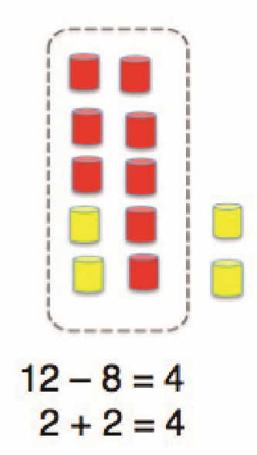S: 10.

T: If I subtract the red objects, what is left?

S: 2.

T: What subtraction sentence takes away 8?

S: 10 – 8 = 2.

T: (Place one yellow object next to the ten.) Let’s subtract 8 again.

T: How many objects are left (point to the 2 and 1)?

T: What addition sentence puts these two sets together?

S: 2 + 1 = 3.

T: 11 – 8 = 2 + 1?

S: Yes.

T: What subtraction sentence have we modeled?

S: 11 – 8 = 3.

T: (Place another yellow object next to the ten.) What subtraction sentence takes away 8?

S: 12 – 8 = 4.

T: What addition sentence puts the remaining sets together?

S: 2 + 2 = 4.

T: 12 – 8 = 2 + 2?

T: Explain 11 – 8 = 2 + 1 and 12 – 8 = 2 + 2 to your partner. Use the models to help you.

Next, students determine whether to subtract from the ten or the ones. At the concrete level, they might arrange their beans to show 14 as modeled on this page with subtracting strips.

T: 14 – 3. Do I have enough ones to subtract 3 from the ones?

S: Yes.

T: Subtract 3 from 4. 14 – 3 is? (Cover 3 with subtracting strip as pictured below.)

S: 11.

T: Use addition to put together the two parts.

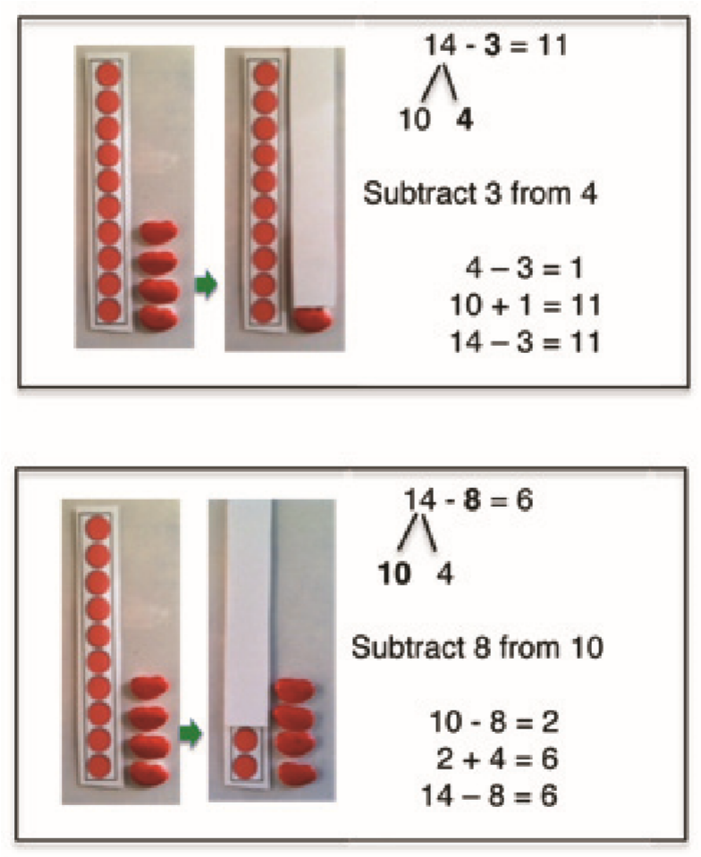S: 10 + 1 = 11.

T: 14 – 8. Do I have enough ones to subtract 8 from the ones?

S: No.

T: Subtract 8 from the ten. 14 – 8 is? (Cover 8 with subtracting strip as pictured to the right.)

S: 6.

T: Use addition to put together the two parts.

S: 2 + 4 = 6.

T: 14 – 3 we subtracted from the ones. 14 – 8 we subtracted from the?

S: Ten.

T: Show me the number 13 with your ten and ones counters. (Students show a column of 10 and a column of 3 to its right.)

T: 13 – 8. Use your subtraction strip to subtract from either the ten or the ones.

T: The full number sentence is?

S: 13 – 8 = 5.

T: Did you subtract from the ten or the ones?

S: The ten.

T: Let’s do another. 15 – 2. (Students show 10 and 5, and then cover 2 of the 5 ones.)

T: The full number sentence is?

S: 15 – 2 = 13.

Quickly continue with other examples alternating between taking from the ones and taking 8 from the ten and asking them from which they subtracted, the ten or the ones. Using personal white boards, students record solutions with number bonds. If they still need the models, give them a ten-strip and beans with which to work.

T: Talk to your partner. How does 10 – 9 help you to solve 13 – 9?

T: How does 10 – 8 help you to solve 12 – 8?

Note: Just as in the previous lessons, the goal is for students to achieve fluency over time by recognizing connections and developing mental strategies that support their mastery of standard 2.OA.2. In addition to subtracting from 10 with a common minuend and subtracting from 10 with a common difference, it is also imperative that students have significant amounts of mixed practice as the year progresses.

The problems below are modeled for use in fluency activities throughout the year as you develop fluency with sums and differences to 20, with an emphasis on using 10.

If there is time within today’s lesson, you may advance to these problems.

Subtract from 10 with a common minuend.

|  |  |
| --- | --- |
|  | NOTES ON  PACING: |
| The work thus far takes the entire 26 minutes. Concept 2 and Concept 3 problems are modeled for use in fluency activities throughout the year as you develop fluency with sums and differences to 20, with an emphasis on using 10. If there is time within the day’s lesson, you may want to advance to Concept 2 and Concept 3 problems.  There are clearly other strategies for subtracting from the teens such as counting back and adding on. However, the “take from ten” strategy develops the important skill of breaking apart a unit relevant to work with place value, measurement, units, and fractions. | |

11 – 2; 11 – 3; 11 – 4; 11 – 5; 11 – 6; 11 – 7; 11 – 8; 11 – 9.

12 – 3; 12 – 4; 12 – 5; 12 – 6; 12 – 7; 12 – 8; 12 – 9.

13 – 4; 13 – 5; 13 – 6; 13 – 7; 13 – 8; 13 – 9.

14 – 5; 14 – 6; 14 – 7; 14 – 8; 14 – 9.

15 – 6; 15 – 7; 15 – 8; 15 – 9.

16 – 7; 16 – 8; 16 – 9.

17 – 8; 17 – 9.

18 – 9.

Subtract from 10 with a common difference. Over time, present students with opportunities to realize that when subtracting from 12, for example, we always are adding back the 2 ones.

11 – 2; 12 – 3; 13 – 4; 14 – 5; 15 – 6; 16 – 7; 17 – 8; 18 – 9.

11 – 3; 12 – 4; 13 – 5; 14 – 6; 15 – 7; 16 – 8; 17 – 9.

11 – 4; 12 – 5; 13 – 6; 14 – 7; 15 – 8; 16 – 9.

11 – 5; 12 – 6; 13 – 7; 14 – 8; 15 – 9.

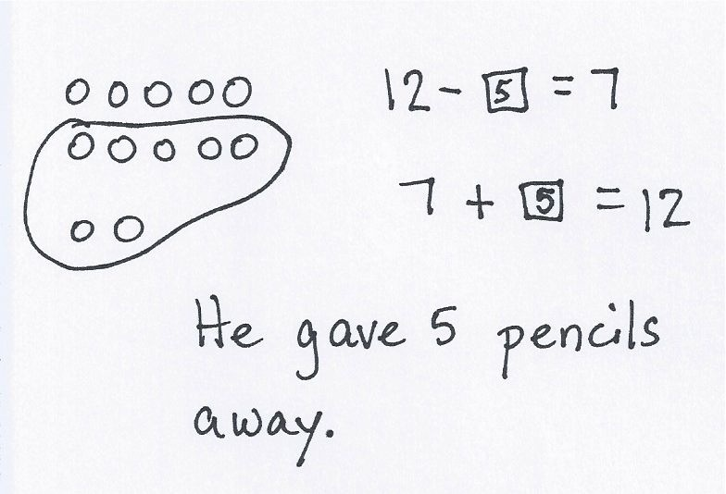11 – 6; 12 – 7; 13 – 8; 14 – 9.

Application Problems (17 minutes)

Problem 1

Pencils come 12 to a package. Shane gives some pencils to his friends. Now he has 7 left. How many pencils did he give away?

Description: G2-M1-TB-L5 sketchProblem 2

Sylvia has a dime and three pennies. A friend asked her for 8 cents.

* What can Sylvia do to be able to give her friend 8 cents?
* How much money would she have left after giving away 8 cents?

**MP.1**

Note: Today’s problems provide practice decomposing to subtract from a ten. Some students may simply know the answer, so it is important to establish the purpose of the application portion of each lesson. It is the time to focus on understanding the situation presented in the problem and representing that situation with a drawing and an equation. It is also the time for students to share their representations and their ways of thinking, which can help more students access problem-solving strategies. Below is a sample script to guide students through Problem 2.

S: (Students read chorally.)

T: (Model one dime and three pennies.) Count the value of the money. At the signal tell me your answer. (Signal.)

|  |  |
| --- | --- |
|  | NOTES ON  MULTIPLE MEANS OF REPRESENTATION: |
| Since the Problem Set does not include the pictorial or concrete, invite tactile learners to use their beans and subtraction strips to model the problems.  The goal in both making a 10 and taking from 10 is for students to master mental math. An important bridge is visualization. Have them use a ten-frame card, but flip it over so they cannot see the units. Allow students to peek if they must, but encourage them to visualize the quantity next time. | |

S: 13!

T: 13 what? Remember to always state the unit.

S: 13 cents!

**MP.1**

T: Talk to your partner about how Sylvia can give her friend 8 cents.

S: She can’t. → Yeah, she can, she has 13 cents and 13 is more than 8. → We can switch a dime for ten pennies. → Oh, yeah, then there are enough pennies to give 8.

Listen as you circulate and provide advancing questions to move students forward on this continuum. At times you might want to speak very quietly, and at other times you might want to speak loudly enough that the whole class has access to the hint.

T: As I moved around the room I heard lots of students suggesting that Sylvia could trade her dime for ten pennies. Thumbs up if this was your idea.

T: (Teacher models the exchange, laying them out in a ten-frame format.) Look at the model. To give her friend 8 cents, should Sylvia take the money from the ten pennies or from the three pennies? Put the answer in your mind and wait for the signal. (Signal.)

S: The ten!

T: (Cover the 10.) Can I take 8 from 3?

S: No!

T: (Cover the 3.) Can I take 8 from 10?

S: Yes!

T: Yes, because you have enough.

T: Imagine Sylvia gives her friend the eight pennies. Turn and talk to your partner about how many pennies are left in all. (Pause.) At the signal tell me how many. (Signal.)

S: 5!

T: (Take the eight pennies away from ten.) How many were left from the dime? (Pause.) Wait for the signal. (Signal.)

S: 2!

T: How many were left from the extra pennies? (Isolate the set with your hands.)

S: 3!

T: What addition sentence combines these?

**MP.1**

S: 2 + 3 = 5!

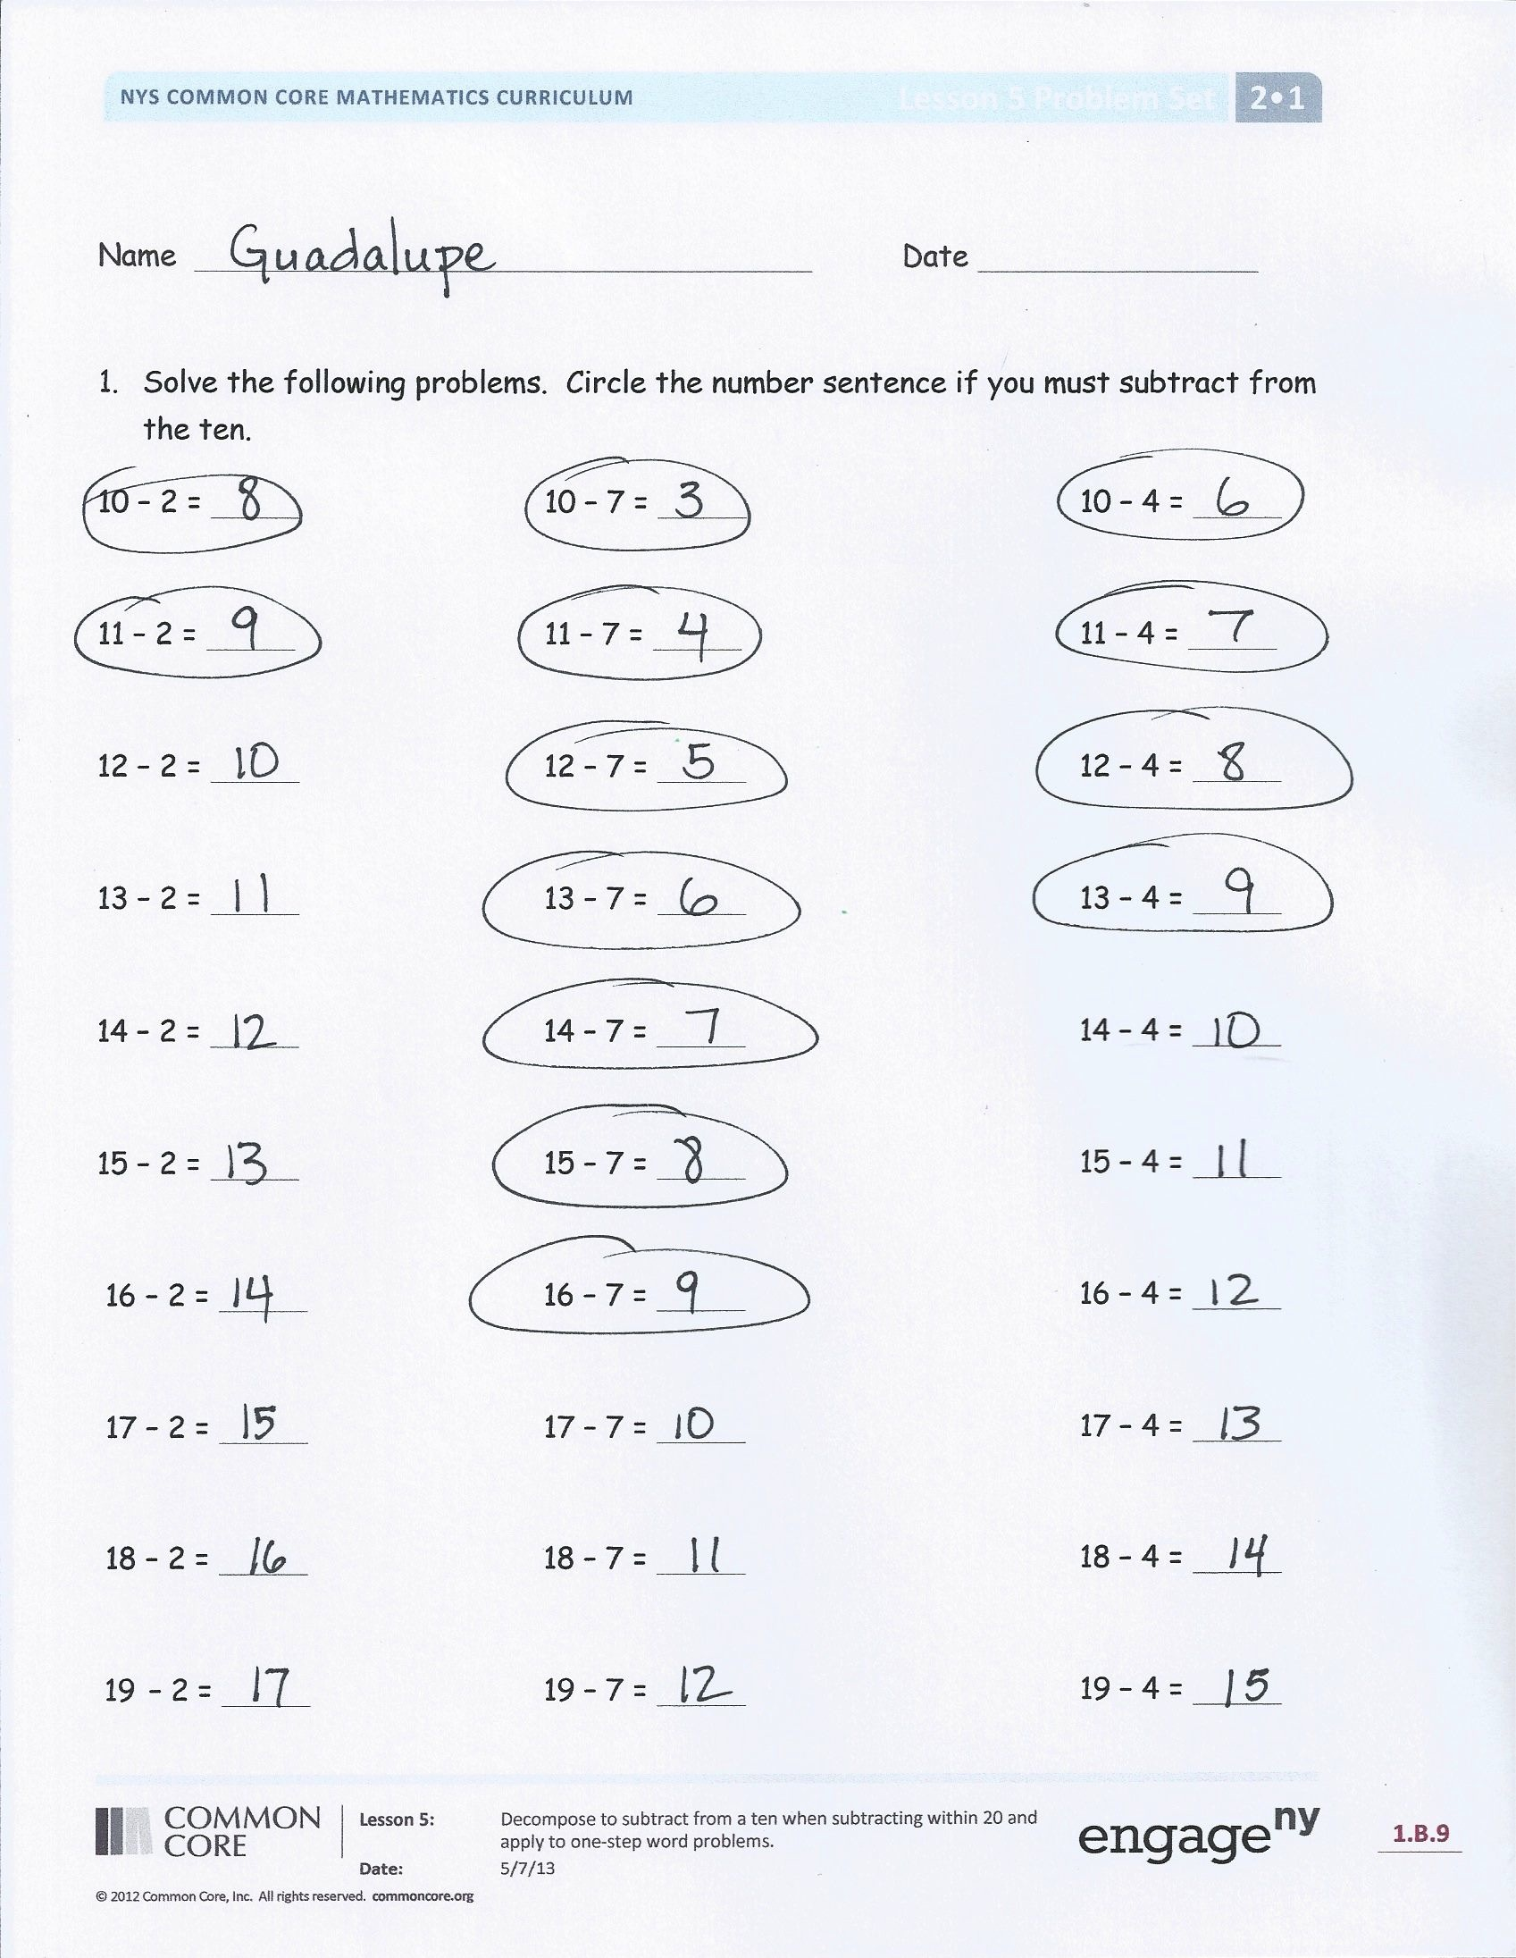T: (Write the number sentence 13 – 8 = 2 + 3). Turn and talk to your partner about what each number means in this number sentence.

Problem Set (10 minutes)

Students should do their personal best to complete the Problem Set within the allotted 10 minutes. For some classes, it may be appropriate to modify the assignment by specifying which problems they work on first. Some problems do not specify a method for solving. Students solve these problems using the RDW approach used for Application Problems.

On this Problem Set, we suggest all students begin with the first column on page 1, then move on to item 4. Possibly leave the remaining columns of problems and items 2 and 3 to the end if they still have time.

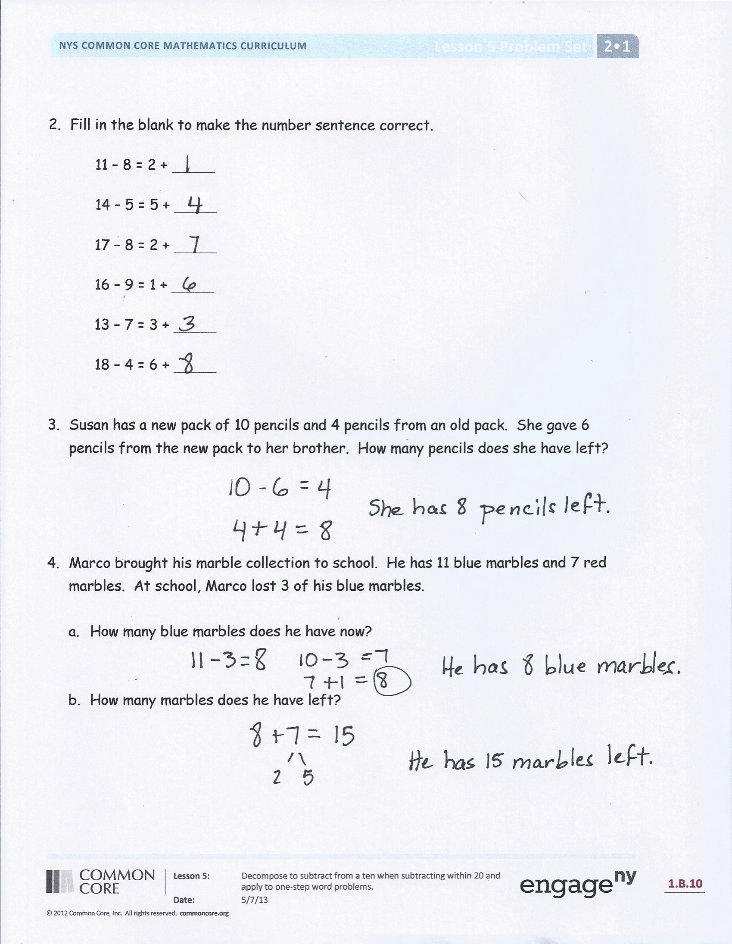Student Debrief (10 minutes)

**Lesson Objective:** Decompose to subtract from a ten when subtracting within 20 and apply to one-step word problems.

The Student Debrief is intended to invite reflection and active processing of the total lesson experience.

Invite students to review their solutions for the Problem Set. They should check work by comparing answers with a partner before going over answers as a class. Look for misconceptions or misunderstandings that can be addressed in the Debrief. Guide students in a conversation to debrief the Problem Set and process the lesson. You may choose to use any combination of the questions below to lead the discussion.

* Let’s look at the first column on the Problem Set. How does knowing 10 – 2 help me solve the rest of the problems?
* What is the relationship of the problems in Column 2?
* What basic fact helps me solve the problems in Column 2? Column 3?
* In number 2, 11 – 8 = 2 + _____, where did the 2 come from?

Exit Ticket

After the Student Debrief, instruct students to complete the Exit Ticket. A review of their work will help you assess the students’ understanding of the concepts that were presented in the lesson today and plan more effectively for future lessons. You may read the questions aloud to the student.

Name Date

1. Solve the following problems. Circle the number sentence if you must subtract from the ten.

10 – 2 = 10 – 7 = 10 – 4 =

11 – 2 = 11 – 7 = 11 – 4 =

12 – 2 = 12 – 7 = 12 – 4 =

13 – 2 = 13 – 7 = 13 – 4 =

14 – 2 = 14 – 7 = 14 – 4 =

15 – 2 = 15 – 7 = 15 – 4 =

16 – 2 = 16 – 7 = 16 – 4 =

17 – 2 = 17 – 7 = 17 – 4 =

18 – 2 = 18 – 7 = 18 – 4 =

1. – 2 = 19 – 7 = 19 – 4 =
2. Fill in the blank to make the number sentence correct.

11 – 8 = 2 +

14 – 5 = 5 +

17 – 8 = 2 +

16 – 9 = 1 +

13 – 7 = 3 +

18 – 4 = 6 +

1. Susan has a new pack of 10 pencils and 4 pencils from an old pack. She gave 6 pencils from the new pack to her brother. How many pencils does she have left?
2. Marco brought his marble collection to school. He has 11 blue marbles and 7 red marbles. At school, Marco lost 3 of his blue marbles.
   1. How many blue marbles does he have now?
   2. How many marbles does he have left?

Name Date

Complete each set.

15 – 9 14 – 6

/\ /\

__ __ __ __

10 – 9 = 10 – 6 =

1 + 5 = 4 + 4 =

15 – 9 = 14 – 6 =

11 – 8 12 – 7

/\ /\

__ __ __ __

10 – = 10 – =

+ 1 = + 2 =

11 – 8 = 12 – 7 =

Name Date

1. Solve the following problems. Circle the number sentence if you must subtract from the ten.

10 – 3 = 10 – 5 = 10 – 6 =

11 – 3 = 11 – 5 = 11 – 6 =

12 – 3 = 12 – 5 = 12 – 6 =

13 – 3 = 13 – 5 = 13 – 6 =

14 – 3 = 14 – 5 = 14 – 6 =

15 – 3 = 15 – 5 = 15 – 6 =

16 – 3 = 16 – 5 = 16 – 6 =

17 – 3 = 17 – 5 = 17 – 6 =

18 – 3 = 18 – 5 = 18 – 6 =

19 – 3 = 19 – 5 = 19 – 6 =

1. Fill in the blank to make the number sentence correct.

14 – 8

10 4

10 – 8 = 2 This is where the 2 comes from.

We have 4 left so the answer is:

2 + **4**

14 – 8 = 2 +

15 – 6 = 4 +

18 – 9 = 1 +

16 – 7 = 3 +

11 – 5 = 5 +

13 – 4 = 6 +

1. Mrs. Jones bought 12 eggs from the store in the morning. Her husband brought home 5 more eggs in the evening. They used 8 of the eggs for dinner. How many eggs do they have left?
2. 11 pink roses and 7 red roses grew in Mrs. Thompson’s garden. She gave away 9 of the pink roses to her neighbor. How many roses does she have left?