Math News
Grade 1, Module 1, Topic F Fall 2014
1st Grade Math
Module 1: Sums and Differences to 10
Math Parent Letter
This document is created to give parents and students a better understanding of the math concepts found in Eureka Math (© 2013 Common Core, Inc.) that is also posted as the Engage New York material which is taught in the classroom. Module 1 of Eureka Math (Engage New York) covers Sums and Differences to 10. This newsletter will discuss Module 1, Topic F.
Topic F. Development of Addition Fluency Within 10

Words to know
- Doubles | - Doubles +1

Things to Remember!

Focus Area– Topic F
Development of Addition Fluency Within 10

Write the double and the double plus 1 sentence for the 5 group cards

 |  | 5 |  | 3
2 + 2 = 4 |  | 5 + 5 = 10 |  | 3 + 3 = 6
2 + 3 = 5 |  | 5 + 6 = 11 |  | 3 + 4 = 7

Solve the number sentences. Use the key to color. Once the box is colored you do not need to color it again.

Color doubles yellow
Color +1 blue
Color +2 green
Color double +1 orange

6 + 2 = _____ | 5 + 1 = _____ | 4 + 5 = _____
2 + 2 = _____ | 3 + 2 = _____ | 8 + 7 = _____
10 = 2 + ____ | 8 = 4 + ____ | ____ = 4 + 3
10 = 5 + ____ | 6 = 3 + _____ | 7 = 5 + ____

Related Fact Ladder

2
9
6
4
4
5
8
15
7
2
5
3

Objective of Topic F
1 | 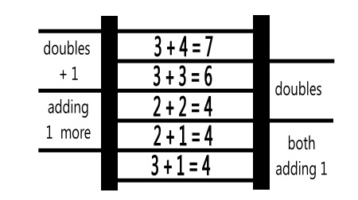  Visualize and solve doubles and doubles plus 1 with 5-group cards.
2 | Look for and make use of repeated reasoning on the addition chart by solving and analyzing problems with common addends.
3 | Look for and make use of structure on the addition chart by looking for and coloring problems with the same total.
4 | Practice to build fluency with facts to 10.

