Math News
Grade 1, Module 1, Topic E Fall 2014
1st Grade Math
Module 1: Sums and Differences to 10
Math Parent Letter
This document is created to give parents and students a better understanding of the math concepts found in Eureka Math (© 2013 Common Core, Inc.) that is also posted as the Engage New York material which is taught in the classroom. Module 1 of Eureka Math (Engage New York) covers Sums and Differences to 10. This newsletter will discuss Module 1, Topic E.
Topic E. The Commutative Property of Addition and the Equal Sign

Words to know
- Commutative Property

Things to Remember!

Commutative Property

If 8 + 3 = 11 is known, then 3 + 8 is also known.

Focus Area– Topic E
The Commutative Property of Addition and the Equal Sign

Write an expression that matches the two groups. If the groups match, write the equal sign between the expressions.

Add. Color the balloons that match the number in the think bubble. Find the expressions that are equal. Connect them below with = to make true number sentences.

Write the number sentences to match the number bonds.

 | 3 | + | 4 | = | 7
 | 4 | + | 3 | = | 7

 | 2 | + | 7 | = | 9
 | 7 | + | 2 | = | 9

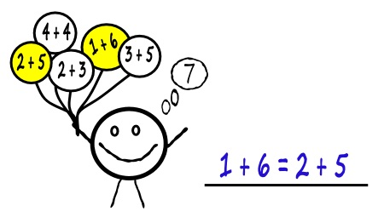

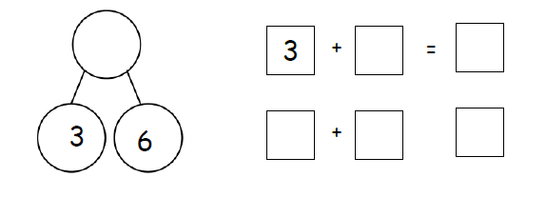
11
8
11
8
3
=

8
3
11

Objective of Topic E
1 | Understand the meaning of the equal sign by pairing equivalent expressions and constructing true number sentences.
2 | Represent the same story scenario with addends repositioned (the commutative property).
3 | Apply the commutative property to count on from a larger addend.

