Math News
Grade 1, Module 1, Topic C Fall 2014
1st Grade Math
Module 1: Sums and Differences to 10
Math Parent Letter
This document is created to give parents and students a better understanding of the math concepts found in Eureka Math (© 2013 Common Core, Inc.) that is also posted as the Engage New York material which is taught in the classroom. Module 1 of Eureka Math (Engage New York) covers Sums and Differences to 10. This newsletter will discuss Module 1, Topic C.
Topic C. Counting On from Embedded Numbers

Words to know
- Unknown | - Equations

Things to Remember!

There are many types of math story problems. Students will learn how to solve a variety of problems in Topic C. Students will be introduced to the concept of unknown in a math story. The unknown of the math story is the number that is needed to solve the story. The number that will answer the question asked. In the first word problem on this page, the unknown is the number of cats Tracy has. In the second problem it is the number of robots Logan brought over, and in the third problem it is represented by a question mark.

Focus Area– Topic C
Counting On from Embedded Numbers

Students will work with story problems to solve equations. (an equation is a math sentence with an equal sign.)

Tracy has 3 orange cats and 4 white cats. How many cats does Tracy have?

Luke has 3 robots. His friend Logan came over with some more. Together they had 7 robots. How many robots did Logan bring over?

Use the number sentences to draw a picture, and fill in the number bond to tell a math story.

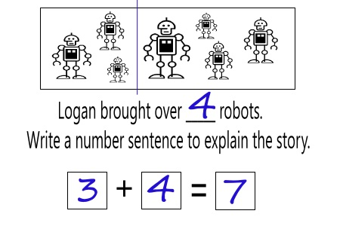

Objective of Topic C
1 | Solve add to with result unknown and put together with result unknown math stories by drawing, writing equations, and making statements of the solution.
2 | Solve put together with result unknown math stories by drawing and using 5-group cards.
3 | Solve add to with change unknown math stories as a context for counting on by drawing, writing equations, and making statements of the solution.
4 | Solve add to with change unknown math stories using 5-groups.
5 | Tell put together with result unknown, add to with result unknown, and add to with change unknown stories from equations.

