Math News

Grade 1, Module 1, Topic B Fall 2014

1st Grade Math

Module 1: Sums and Differences to 10

Math Parent Letter

This document is created to give parents and students a better understanding of the math concepts found in Eureka Math (© 2013 Common Core, Inc.) that is also posted as the Engage New York material which is taught in the classroom. Module 1 of Eureka Math (Engage New York) covers Sums and Differences to 10. This newsletter will discuss Module 1, Topic B.

Topic B. Counting On from Embedded Numbers

**Words to know**

|  |  |
| --- | --- |
| * Expression | * Addend |
| * Number Bond |  |

Things to Remember!

Students will learn the number bonds for 6, 7, 8, 9, and 10.

Focus Area– Topic B

*Counting On from Embedded Numbers*

Students will work on counting on from one embedded number or part to totals of 6, 7, 8, and 9 and generate all addition **expressions** for each total.

Ex. Fill in the missing part of the number bond and count on to find the total. Then write 2 addition sentences for each number bond.

Ex. Circle the part. Count on to show 7 with the pictures and number bond. Write the expressions.

Circle 3. How many more does 3 need to make 7?

Ex. Circle the pairs of numbers that make 8. Complete the number bond and show 2 different ways to make 8.

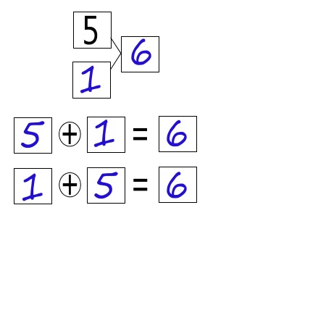

C:\Users\thardy\AppData\Local\Microsoft\Windows\Temporary Internet Files\Content.IE5\FN1PUFI9\MC900233118[1].wmf

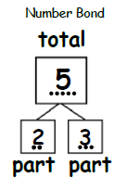

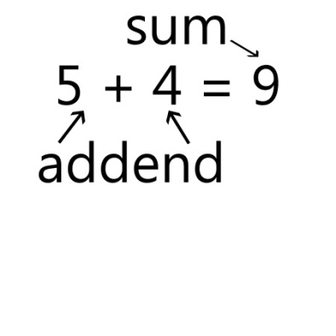

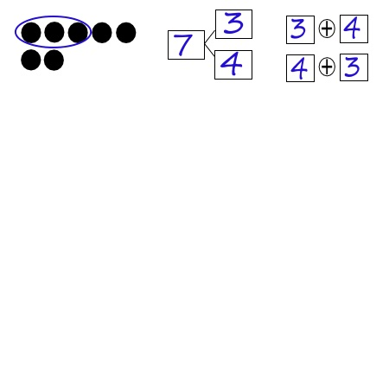

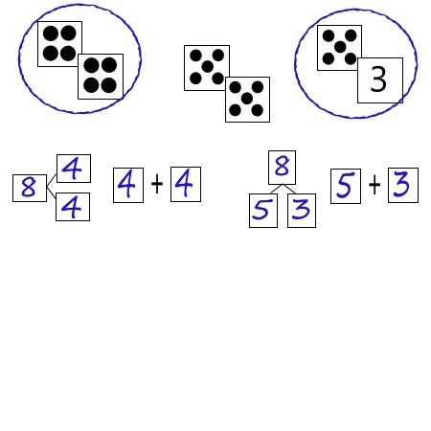

|  |  |
| --- | --- |
| Objective of Topic B | |
| 1 | Represent *put together* situations with number bonds. Count on from one embedded number or part to totals of 6 and 7 and generate all addition expressions for each total. |
| 2 | Represent *put together* situations with number bonds. Count on from one embedded number or part to totals of 8 and 9 and generate all expressions for each total. |
| 3 | Represent all the number pairs of 10 as number bond diagrams from a given scenario and generate all expressions equal to 10. |