Math News
Grade 1, Module 1, Topic A Fall 2014
1st Grade Math
Module 1: Sums and Differences to 10
Math Parent Letter
This document is created to give parents and students a better understanding of the math concepts found in Eureka Math (© 2013 Common Core, Inc.) that is also posted as the Engage New York material which is taught in the classroom. Module 1 of Eureka Math (Engage New York) covers Sums and Differences to 10. This newsletter will discuss Module 1, Topic A.
Topic A. Embedded Numbers and Decompositions

Words to know
- 5 – group | - Number bond
- One more than | - Count on

Things to Remember!

Number bond – shows the whole and the parts of a number
5 – group – a row of five items
Count on – count from one number to the total. Example: 2 + 3 = 5. Start at the larger number (3) and count 2 more (4, 5). Think 3 count 4, 5.
Focus Area– Topic A
Embedded Numbers and Decomposition

Instead of counting all objects, students will work on counting on. Students will review parts of the numbers 1-5 and analyze and describe embedded numbers (to 10) using a 5-group configuration, focusing on parts of 6, 7, 8, and 9. By seeing numbers as a subset of 5 and another subset, this will help with addition and subtraction.
Circle 5 and make a number bond.

Students will also reason about embedded numbers in varied configurations using number bonds:

Number Bond Dashes will be done in order to provide fluency when decomposing numbers. Students will see and describe numbers of objects using 1 more within 5-group configurations. The sentence frame “1 more than ___ is ___ and ___ is 1 more than ___.”
Draw one more in the 5-group. In the box, write the number to describe the new picture.

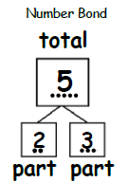

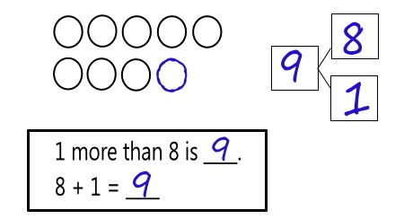
Objective of Topic A
1 | Analyze and describe embedded numbers (to 10) using 5-groups and number bonds.
2 | Reason about embedded numbers in varied configurations using number bonds.
3 | See and describe numbers of objects using 1 more within 5-groups configurations.

